THE LEMON TWIGS ANNOUNCE NEW ALBUM EVERYTHING HARMONY, OUT MAY 5 VIA CAPTURED TRACKS

WATCH THE SOFT, SURREAL MONKEES-ESQUE VIDEO FOR SINGLE “ANY TIME OF DAY” HERE

TAKEN FROM WRITING SESSIONS FOR SHELVED QUIBI INTERACTIVE SHOW ABOUT AN IMAGINARY ’70S BROTHER BAND

PRE-ORDER/SAVE EVERYTHING HARMONY HERE

Critical Praise For Recent Single “Corner Of My Eye”:
"Sublime, lilting Todd Rundgren-like loveliness.” - Sunday Times
"In true Lemon Twigs fashion, sounds like a forgotten slice of 60s baroque pop. Totally perfect, and a little bit heartbreaking." - The Guardian
"A soft and melancholic throwback." - Stereogum
"The soft rock ballad feels reminiscent of folk greats of the ’60s and ’70s." - Consequence
"Sweet, catchy...liking this one a lot.” - Needle Drop
"Allow the Lemon Twigs to transport you to sunny Laurel Canyon on even the dreariest winter day." - AltPress
"A dreamy Beatles-esque ballad." - FLOOD
"As lovely as it is heart-wrenching." - Atwood
"Created a soft rock rock vibe that brings a feeling of early folk music." - MXDWN

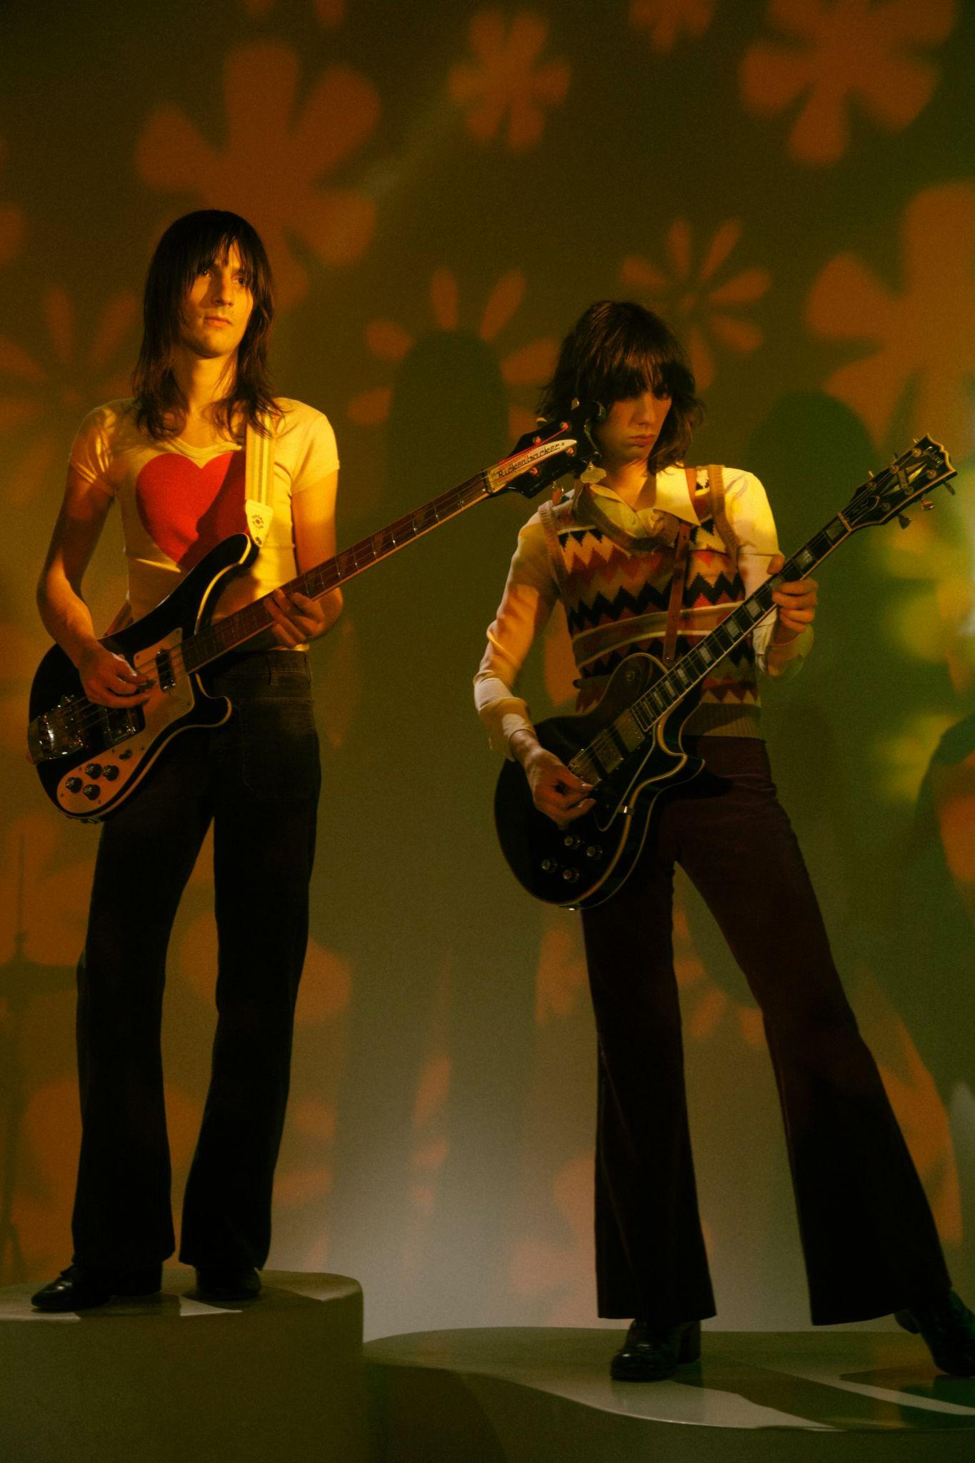
Photo credit: Stephanie Pia

Today, The Lemon Twigs announce the release of their fourth studio album, Everything Harmony, out May 5 via Captured Tracks. Everything Harmony is a tour de force that arrives as a full realization of the brother duo of Brian and Michael D’Addario’s distinct blend of sunny pop vocals with sophisticated acoustic-folk melodies and rich textures, inspired by the likes of Simon & Garfunkel, Arthur Russell and Moondog. The album swings between moments of depression and isolation and episodes of dizzying euphoria. It was written, recorded, produced and engineered entirely by The Lemon Twigs across Manhattan, Brooklyn and San Francisco’s Hyde Street Studios.

The announcement is accompanied by affectionate single “Any Time Of Day,” which follows recent “Corner Of My Eye.” According to director Ambar Navarro, the video for “Any Time Of Day” was “heavily inspired by ’60s television live performances and focusing on the minimal set pieces, referencing The Carpenters, Tom Petty, and especially The Monkees' TV Show and absurd/surreal comedy of that era."

Of the track, The Lemon Twigs say, “We were hired to write material and act in an interactive TV show about an imaginary ’70s brother band. We wrote a bunch of KISS type songs for the soundtrack plus this one. This one wasn’t quite right for the show, so we held it back. For a month in 2019, we filmed all 8 episodes. In the fallout of a high profile lawsuit taken by the company against Quibi, the show was shelved and remains on someone’s hard drive if not completely erased to save space. The song’s about the cyclical nature of life. Everything goes on and on. Out with the old, in with the new!”

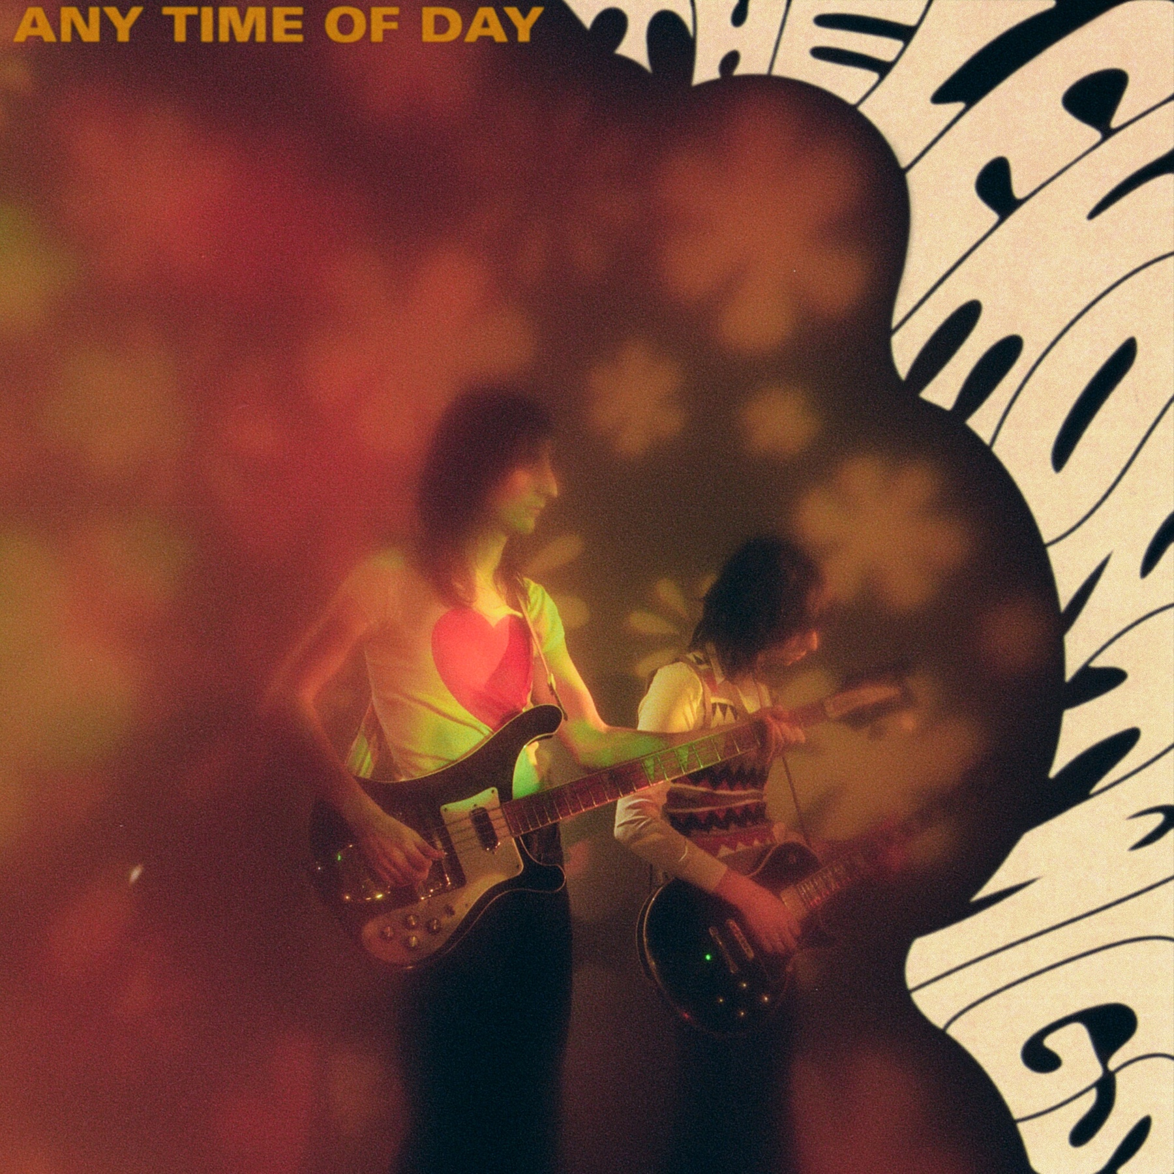

The prodigiously-talented duo first emerged as The Lemon Twigs in 2016 with their debut LP Do Hollywood, whose show stopping melodies mined from every era of rock quickly earned fans in Elton John, Questlove, and Jack Antonoff. Go To School, the ambitious 15-track coming-of-age opus, followed in 2018 and solidified the band’s reputation for building grand walls of sound around an audacious concept. 2020’s Songs For The General Public earned critical praise from NPR, Vice, Teen Vogue, Stereogum and more. The pair recently worked on Weyes Blood’s two most recent albums including 2022’s And in the Darkness, Hearts Aglow as well as with classic rock hero Todd Rundgren on his most recent record, Space Force and with Tim Heidecker on his Fear of Death project.

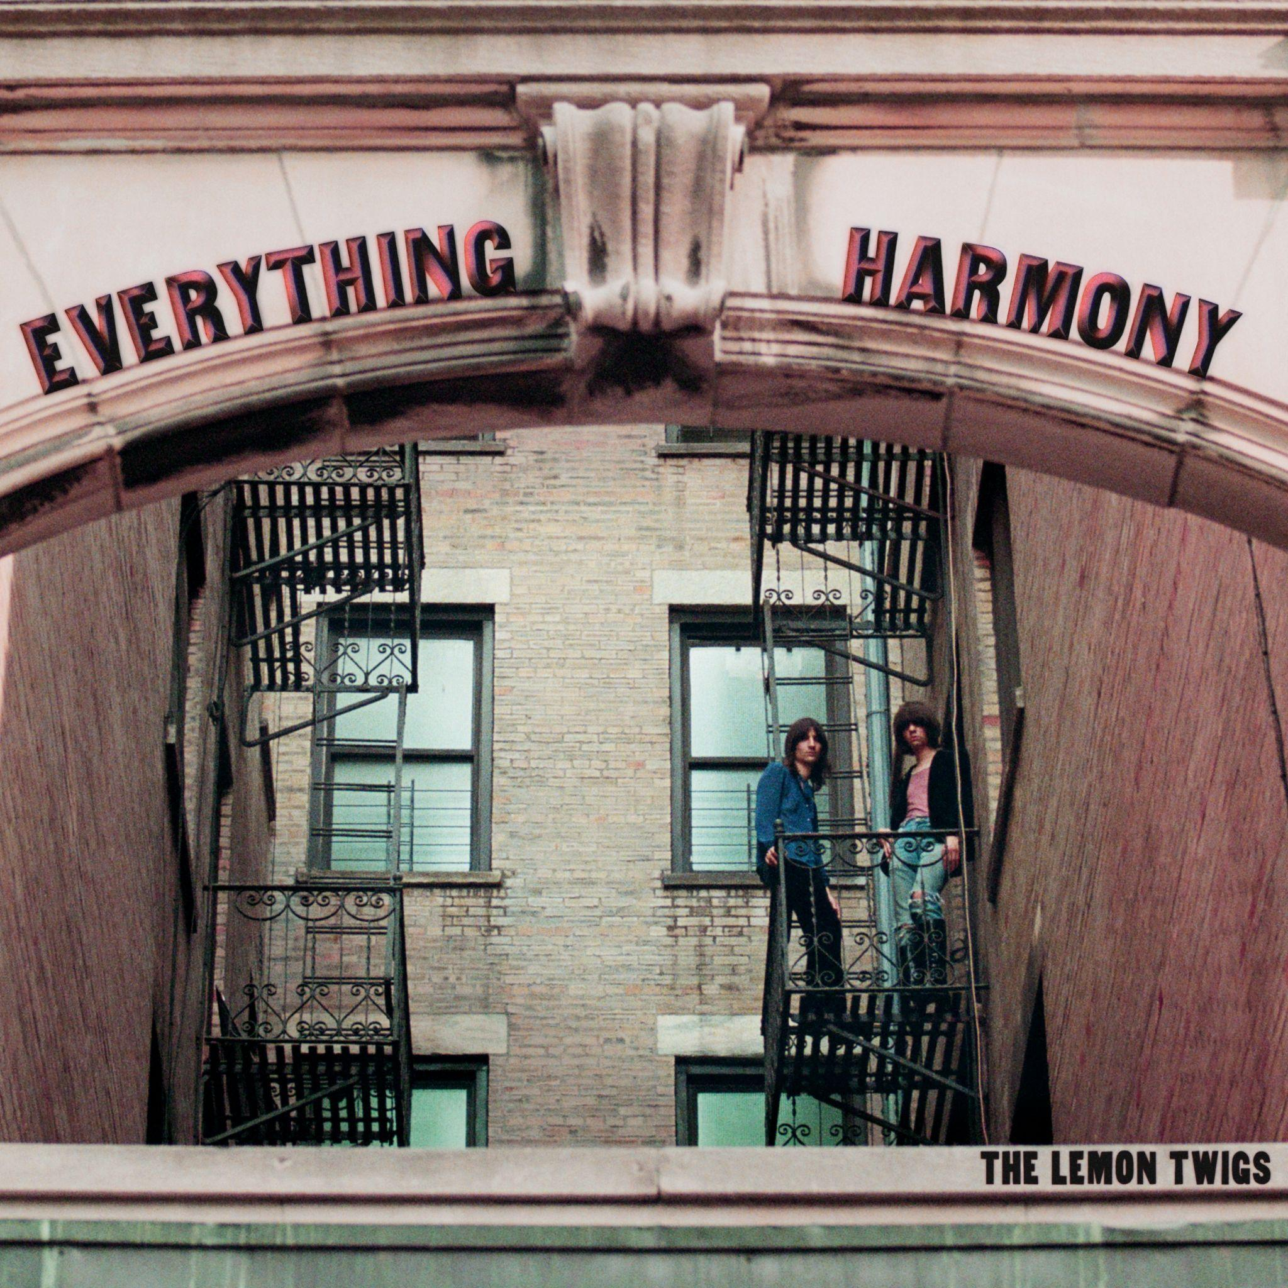

Everything Harmony Tracklisting:
- When Winter Comes Around
- In My Head
- Corner Of My Eye
- Any Time Of Day
- What You Were Doing
- I Don’t Belong To Me
- Every Day Is The Worst Day Of My Life
- What Happens To A Heart
- Still It’s Not Enough
- Born To Be Lonely
- Ghost Run Free
- Everything Harmony
- New To Me

Tour Dates:
April 18 – Atlanta, GA – Terminal West,
April 19 – Nashville, TN – Basement East
April 21 – Dallas, TX – Deep Ellum Art Co
April 22 – Austin, TX – 3Ten ACL Live
April 25 – Tucson, AZ – Club Congress
April 27 – San Diego, CA – Music Box
April 28 – Los Angeles, CA – Troubadour
April 29 – San Francisco, CA – The Chapel
May 1 – Portland, OR – Holocene
May 2 – Seattle, WA – Madame Lou's
May 5 – Minneapolis, MN – Fine Line
May 6 – Chicago, IL – Sleeping Village
May 7 – Chicago, IL – Sleeping Village
May 9 -- Toronto, ON – Great Hall
May 10 – Montreal, QC – Bar Le Ritz PDB
May 12 – Boston, MA – The Sinclair
May 13 – New York, NY – Irving Plaza
May 20 - Amsterdam, NL – London Calling Festival @ Paradiso
May 21 – Lille, FR – Le Grand Mix
May 23 – Berlin, DE – Frannz Club
May 24 – Nancy, FR – L'Autre Canal
May 25 – Paris, FR – La Trianon
May 27 – Brighton, UK – Chalk
May 28 – Bristol, UK – SWX
May 29 – Glasgow, UK – SWG3
May 31 – Manchester, UK – New Century Hall
June 1 – London, UK – Electric Ballroom

THE LEMON TWIGS ONLINE
thelemontwigs.com
@TheLemonTwigs

For more information on The Lemon Twigs, please contact Carrie Tolles (carrie@tcbpr.com), Alison Smith (alison@tcbpr.com) and Claire Marcus (claire@tcbpr.com) at TCB Public Relations

