ANNOUNCE DEBUT SHOW AT LONDON’S EARTH THEATRE ON JUNE 5TH

LISTEN TO THEIR FIRST TRACK ‘LET’S TURN THIS BACK AROUND’ HERE
WATCH THE VIDEO DIRECTED BY KELLY JONES HERE

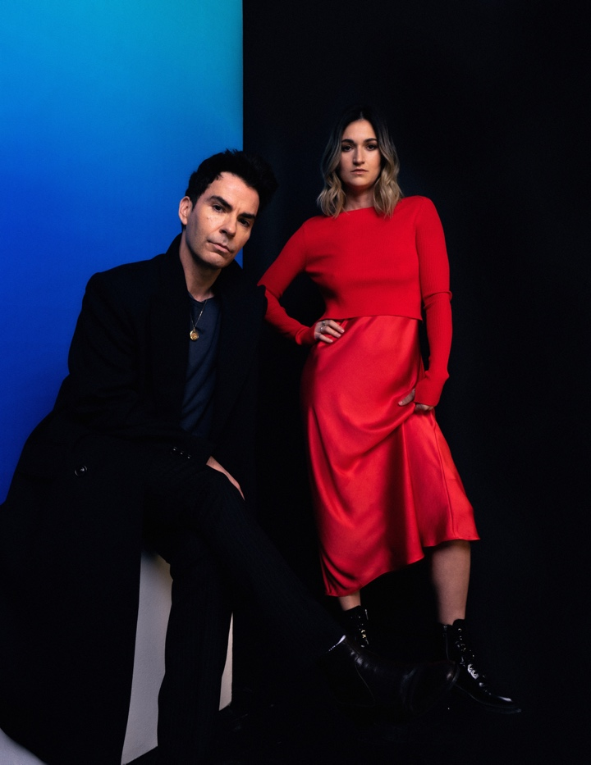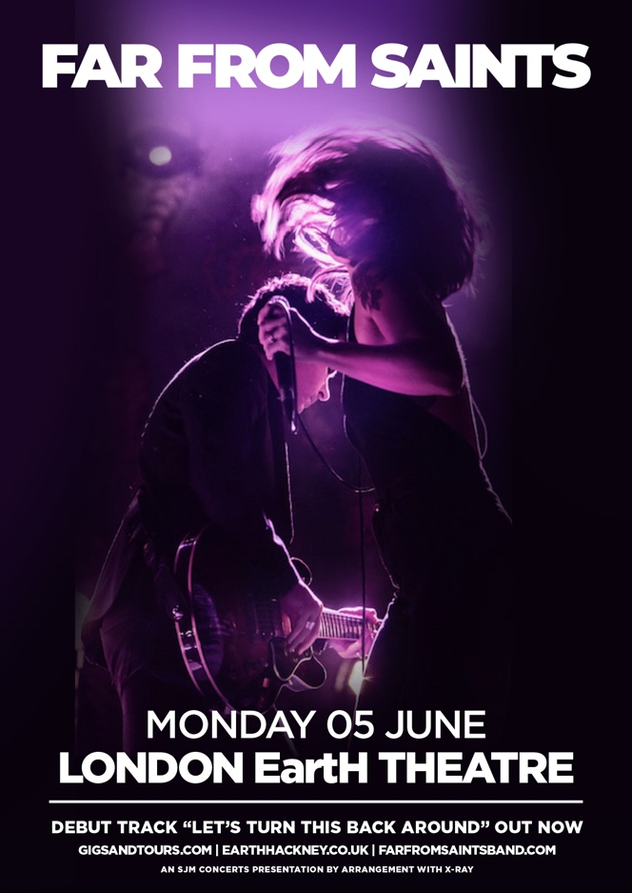

Photo credit: Sophia French

Having recently unveiled their debut track ‘Let’s Turn This Back Around’, Far From Saints today announce details of their debut live show at London’s EartH Theatre on June 5th. ‘Let’s Turn This Back Around’ made an instant impact for Far From Saints, leading to the song receiving its first play from Bob Harris at Radio 2 and then being named as Jo Whiley’s Infatuation. That big introduction was supported by high profile interviews with Jo Whiley and Radio X.

Now Far From Saints - Kelly Jones of Stereophonics with Patty Lynn and Dwight Baker from The Wind and The Wave - announce details of their debut show at London’s EartH Theatre on June 5th. Tickets will go on sale HERE from 9am this Friday, February 17th.

In addition to the London headline show, Far From Saints will also be hitting the festival circuit this summer - expect more details to be confirmed soon.

Kelly Jones says, “Like starting over… our first show at EartH Theatre will be a brand new and exciting experience that we can’t wait to share with you all. We've got a great band, half Welsh and half American revving up to play the new album in its entirety with some extras here n' there!"

The trio first experimented with playing music together when The Wind and The Wave opened for Kelly Jones on his UK solo tour in 2019. They would spend their downtime jamming and writing songs together, and they would team up during Kelly’s set to perform a rapturously received cover of Stevie Nicks and Tom Petty’s ‘Stop Draggin’ My Heart Around’.

After the three songwriters merged their influences, they created a fervent mix of Americana, folk, rock and country influences which very naturally complemented the alchemy and beautiful harmonies crafted by the two vocalists. Those songs were captured organically in two recording sessions spanning just nine days, with the trio producing the project themselves before calling upon the Grammy-nominated Al Clay (Blur, Pixies) for mixing duties. Despite coming together so quickly, their upcoming debut album was held back after the pandemic left Far From Saints an ocean apart. Still captivatingly fresh, the album is now ready to be shared with the world and will be released early this summer.

Follow Far From Saints:
Instagram
Facebook
Twitter
Spotify
Tik Tok

For more information, please contact kat@dedikatedpr.com

