‘S CLUB 7 REUNITED’
A 25th ANNIVERSARY UK AND IRELAND ARENA TOUR

with Bradley, Hannah, Jo, Jon, Paul, Rachel, and Tina

EXTRA DATES ADDED DUE TO PHENOMENAL DEMAND INCLUDING THIRD LONDON SHOW

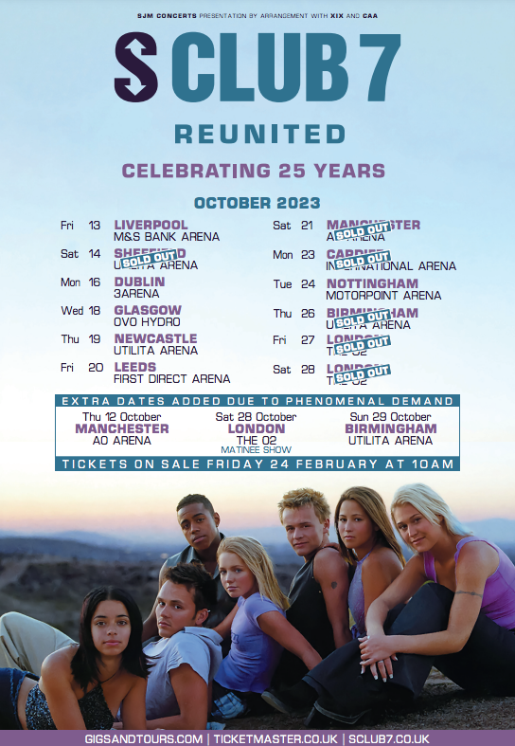

Tuesday 21st February - S Club 7, one of the most successful British pop groups of all time, have today announced extra dates due to phenomenal demand for their reunion tour in celebration of their 25-year legacy.

The S Club 7 Reunited tour will see all seven members – Bradley, Hannah, Jo, Jon, Paul, Rachel, and Tina – come together for a major arena tour across the UK and Ireland. With multiple dates already sold out including two London shows, extra dates have been added in Manchester and Birmingham alongside a matinee show at The O2 (the group’s third date at the venue) this October.

Speaking on coming back together, the band said: “It’s so good to be back!! We have all been so overwhelmed by the response following the tour announcement. Thanks again for all the lovely messages and support, it means the world to us. It’s such fun seeing ourselves back on TV, on the radio and on the front pages of newspapers and being added to playlists…We can’t wait to see you all in October.”

The 25th anniversary tour is an opportunity for S Club 7 fans of every generation to come together and re-experience the timeless pop hits that soundtracked the British charts for five years. Collectively, S Club 7 amassed four UK number one singles with ‘Bring It All Back’, ‘Never Had a Dream Come True’, ‘Don’t Stop Movin’, and ‘Have You Ever’, as well as the UK number one album ‘7’. They recorded 4 studio albums, released 11 singles that all entered the Top 5 UK charts, and went on to sell over 10 million albums worldwide.

The band’s celebrity status was also cemented with their TV shows; Miami 7 and L.A. 7 became record-breaking favourites on children’s TV and were watched by more than 90 million people in over 100 countries – L.A. 7 remains the highest rating programme of all time on CBBC.

With 4 multi-platinum selling albums, 2 BRIT Awards, and 9 number-one international hit singles to their name, S Club 7 are a household name that are once again ready to rise.

Tickets for S Club 7 Reunited extra dates go on sale at 10:00am GMT on Friday 24th February via www.gigsandtours.com and www.ticketmaster.co.uk, with all other dates on sale now. Tickets for Ireland will be available via www.ticketmaster.ie.



Tour Dates

12th October - Manchester, AO Arena – EXTRA DATE
13th October - Liverpool, M&S Bank Arena
14th October - Sheffield, Utilita Arena – SOLD OUT
16th October - Dublin, 3Arena
18th October - Glasgow, OVO Hydro
19th October - Newcastle, Utilita Arena
20th October - Leeds, First Direct Arena
21st October - Manchester, AO Arena – SOLD OUT
23rd October - Cardiff, International Arena – SOLD OUT
24th October - Nottingham, Motorpoint Arena
26th October - Birmingham, Utilita Arena – SOLD OUT
27th October - London, The O2 – SOLD OUT
28th October - London, The O2 – MATINEE – EXTRA DATE
28th October - London, The O2 – EVENING - SOLD OUT
29th October - Birmingham, Utilita Arena – EXTRA DATE

Follow S Club 7 on

Instagram @sclub7
Twitter @sclub7
Facebook S Club 7
YouTube @sclub7

---ends---

For more information, please contact Stuart Bell or Jordan Shepley

stuart.bell@dawbell.com / 0203 327 7180

jordan.shepley@dawbell.com / 07795 474007

