KAMAL. ANNOUNCES HEADLINE LONDON SHOW LAYLOW - 16TH MARCH
RETURNS WITH ADDICTIVE NEW TRACK “FREE FLOW”
‘so here you are, drowning’ MIXTAPE LANDS ON 17TH MARCH
STREAM: https://kamalnw.lnk.to/freeflow
WATCH THE TYRUS-DIRECTED VIDEO: https://www.youtube.com/watch?v=CtVHByJoGek
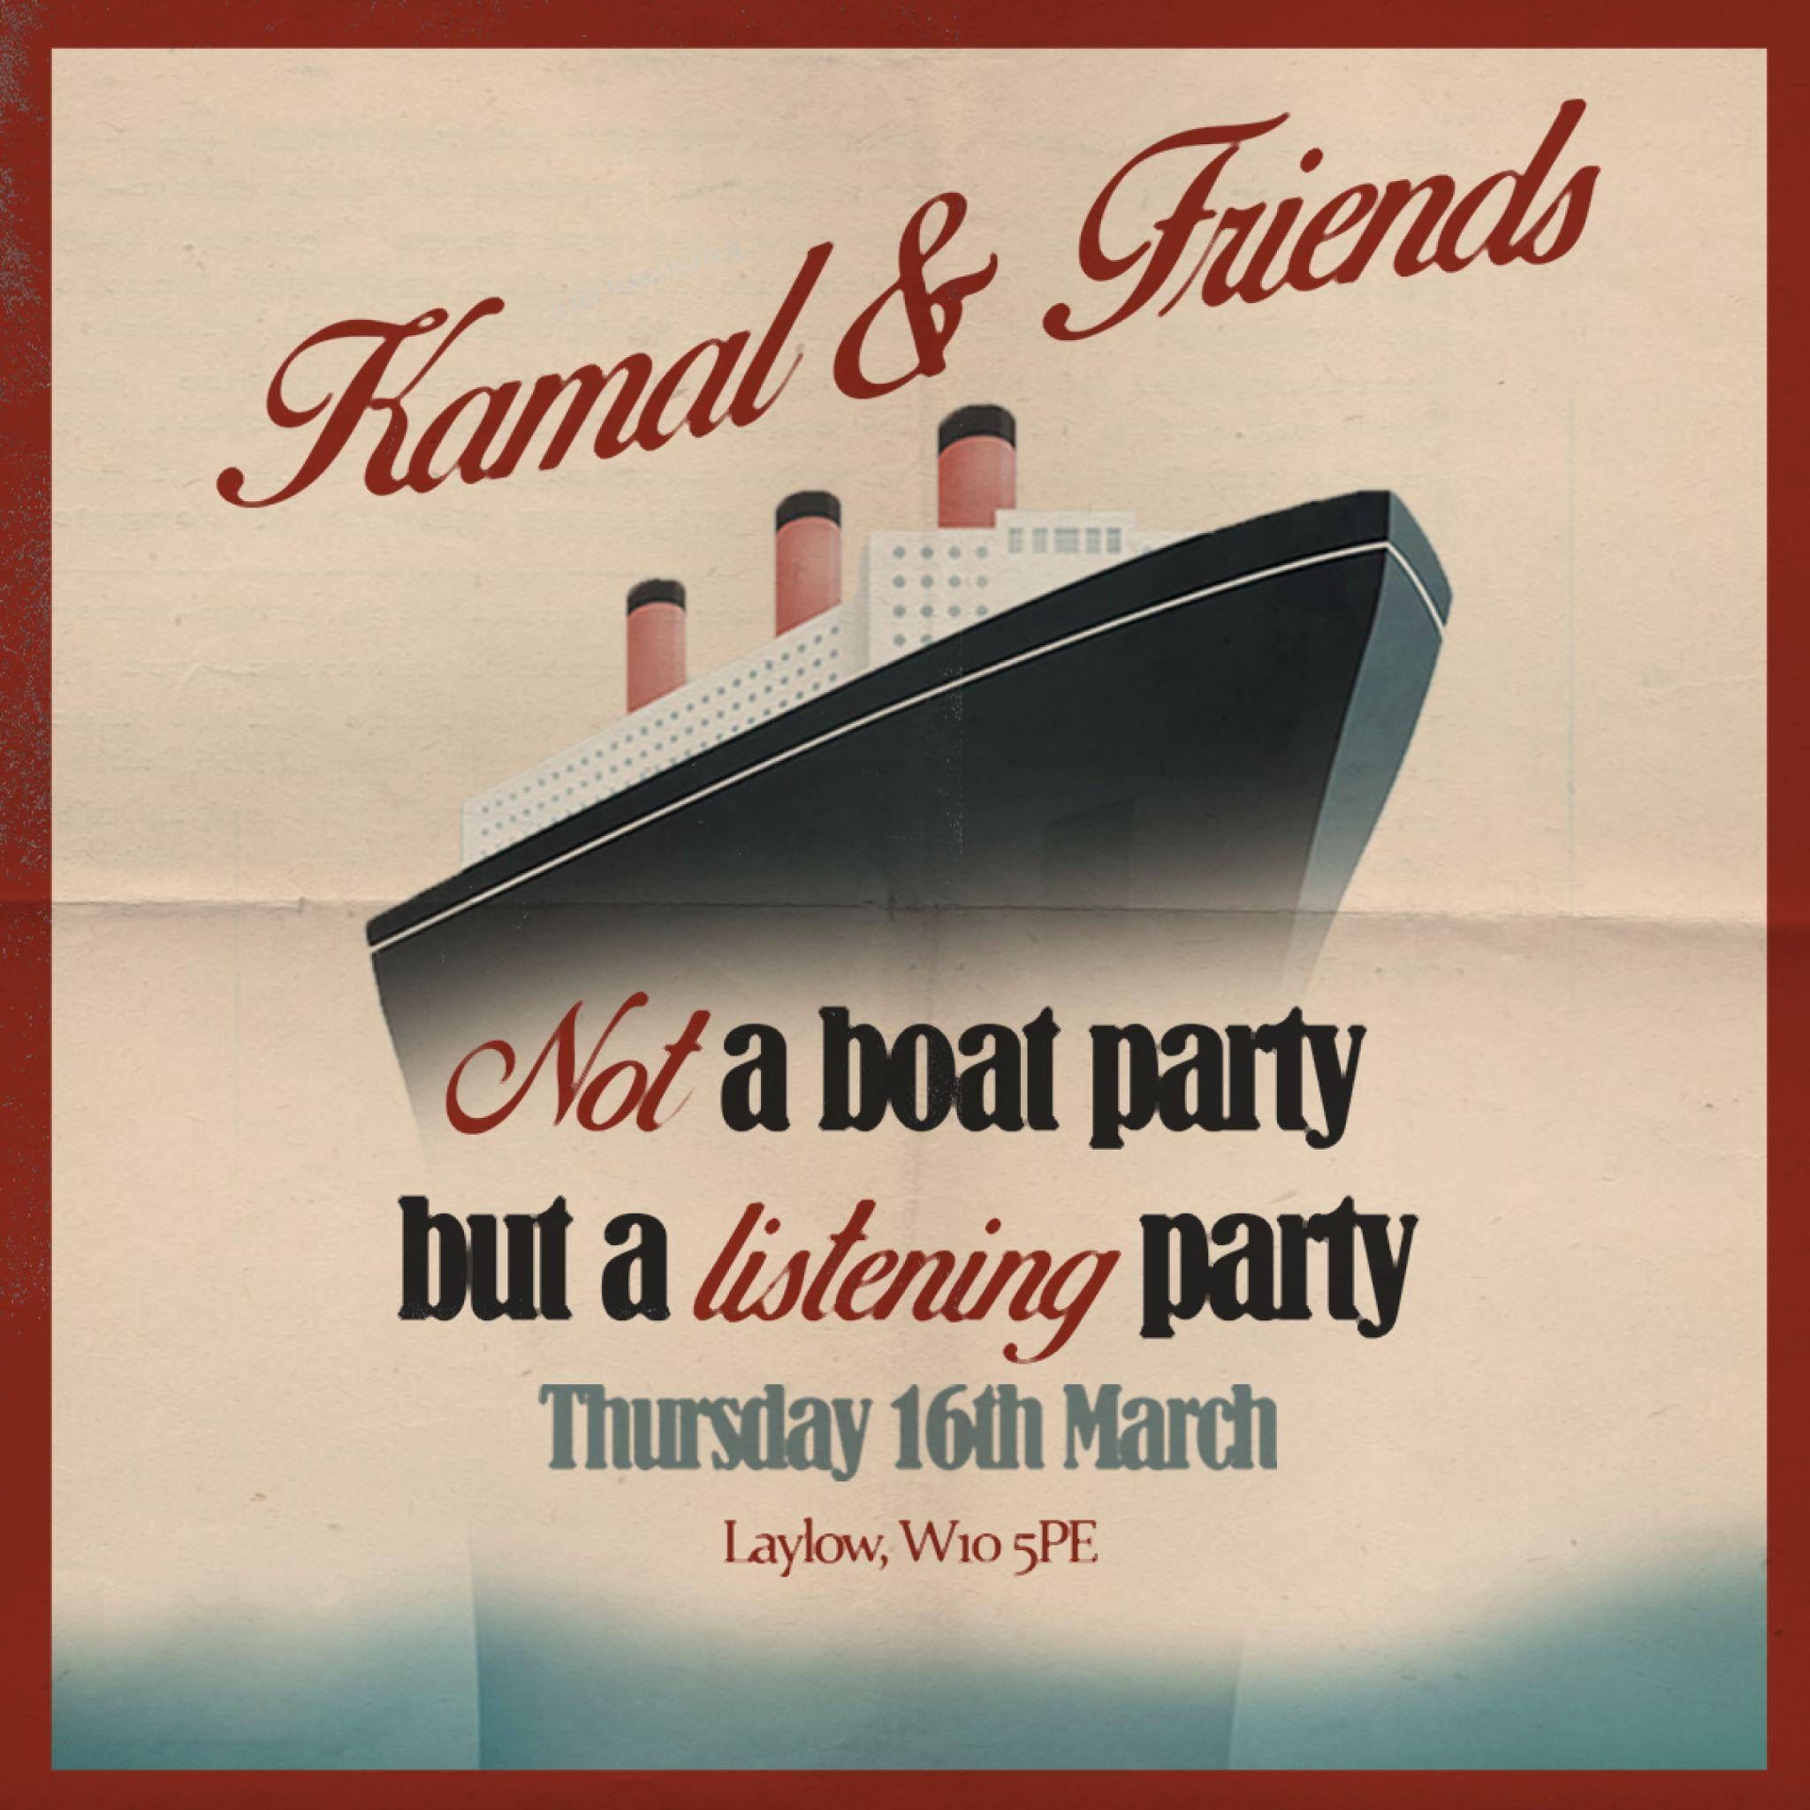
Following the release of his brand new single ‘Free Flow’, Kamal. has today announced the details of a headline London show at Laylow on Thursday 16th March. Performing tracks live from his upcoming ‘so here you are, drowning’ mixtape for the very first time, he will also be joined by some very special friends.

At just 20 years old, North-West London hailing musician Kamal. is on a rapid trajectory. A multi-instrumentalist, Kamal. is Ivor Novello-award nominated, has collaborated with Dave, and amassed an awe-inspiring 250 million streams.
On the horizon is his newly announced ‘so here you are, drowning’ mixtape- which is set for release on March 17th 2023, and Kamal. Has shared his second offering from the forthcoming project - an addictive and emotion-riddled cut titled “Free Flow”. Accompanied by a Tyrus-directed visual that sees Kamal. receiving numerous lyrical stick and poke tattoos, new single “Free Flow” muses on the extreme emotion you feel when you first start dating someone; wondering where you stand, painting a picture of yourself, laying yourself bare.
Kamal.’s new music is a lyrical development from last year’s “nowhere to hide”- an addictive sonic with a poignant lyricism that spoke on the notions of materialism and fulfilment. Kamal. after taking some time out to write music and focus on his craft, has reached his 2.0 era. ‘so here you are, drowning’ is the result of almost two years of writing and documenting the specific feeling of trying to stay afloat; the tensions between codependency and martyrdom in a relationship, and ultimately drowning in it all. It’s title was inspired by Caleb Azumah Nelson’s phenomenal novel ‘Open Water.’
Whilst the new music is a developed sound from Kamal., it also weaves a cohesive thread with his back-catalogue. Kamal.’s music has always been a dose of sweet honey vocals, offered on a sharp knife of realism and honesty, and since his highly anticipated debut EP ‘war outside’ at the end of 2021, Kamal.’s new music has followed seamlessly in the footsteps of previous offerings, including the ethereal cliff-top soaring single “lose”, Billie Eilish endorsed “blue”, fan favorite “homebody”, and of course, the Top-40 single “Mercury”, his collaboration with Brit Award winning rapper Dave.
Kamal. was always destined to be a musician. A skilled pianist, his early influences were found in the likes of Maxwell, D’Angelo, Erykah Badu and Bill Withers. Formulating his own sound, he first began to compose tracks to his ukulele and in 2019, uploaded his first recorded song -“smilingdownthephone” on soundcloud. Since then, he hasn’t looked back - garnering co-signs from the likes of NME, British GQ, British Vogue, i-D, Dazed and more.
The voice of a generation, Kamal. moves with the vision and presence of someone much older than his years. A truly unique artist, his innate musical talent has placed him firmly on the map.
Tickets for the show go on sale Friday 24th February at 10am and will be available from www.gigsandtours.com

Follow Kamal.’s journey here: https://www.instagram.com/Kamal.nw/
For all inquiries please email: joss@wired-pr.co.uk
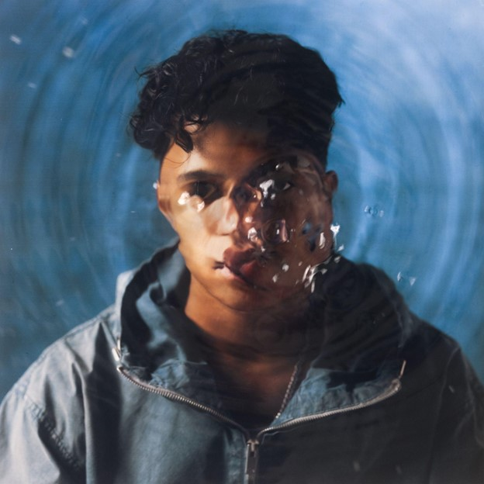
[EP ARTWORK]

