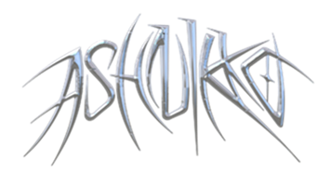
ANNOUNCES DEBUT ALBUM WEEDKILLER
OUT JUNE 2ND

PRE-ORDER NOW
WORLD TOUR ANNOUNCED AND ON SALE 10TH MARCH
INCLUDING 7 UK SHOWS

NEW SINGLE WORMS OUT NOW
LISTEN HERE

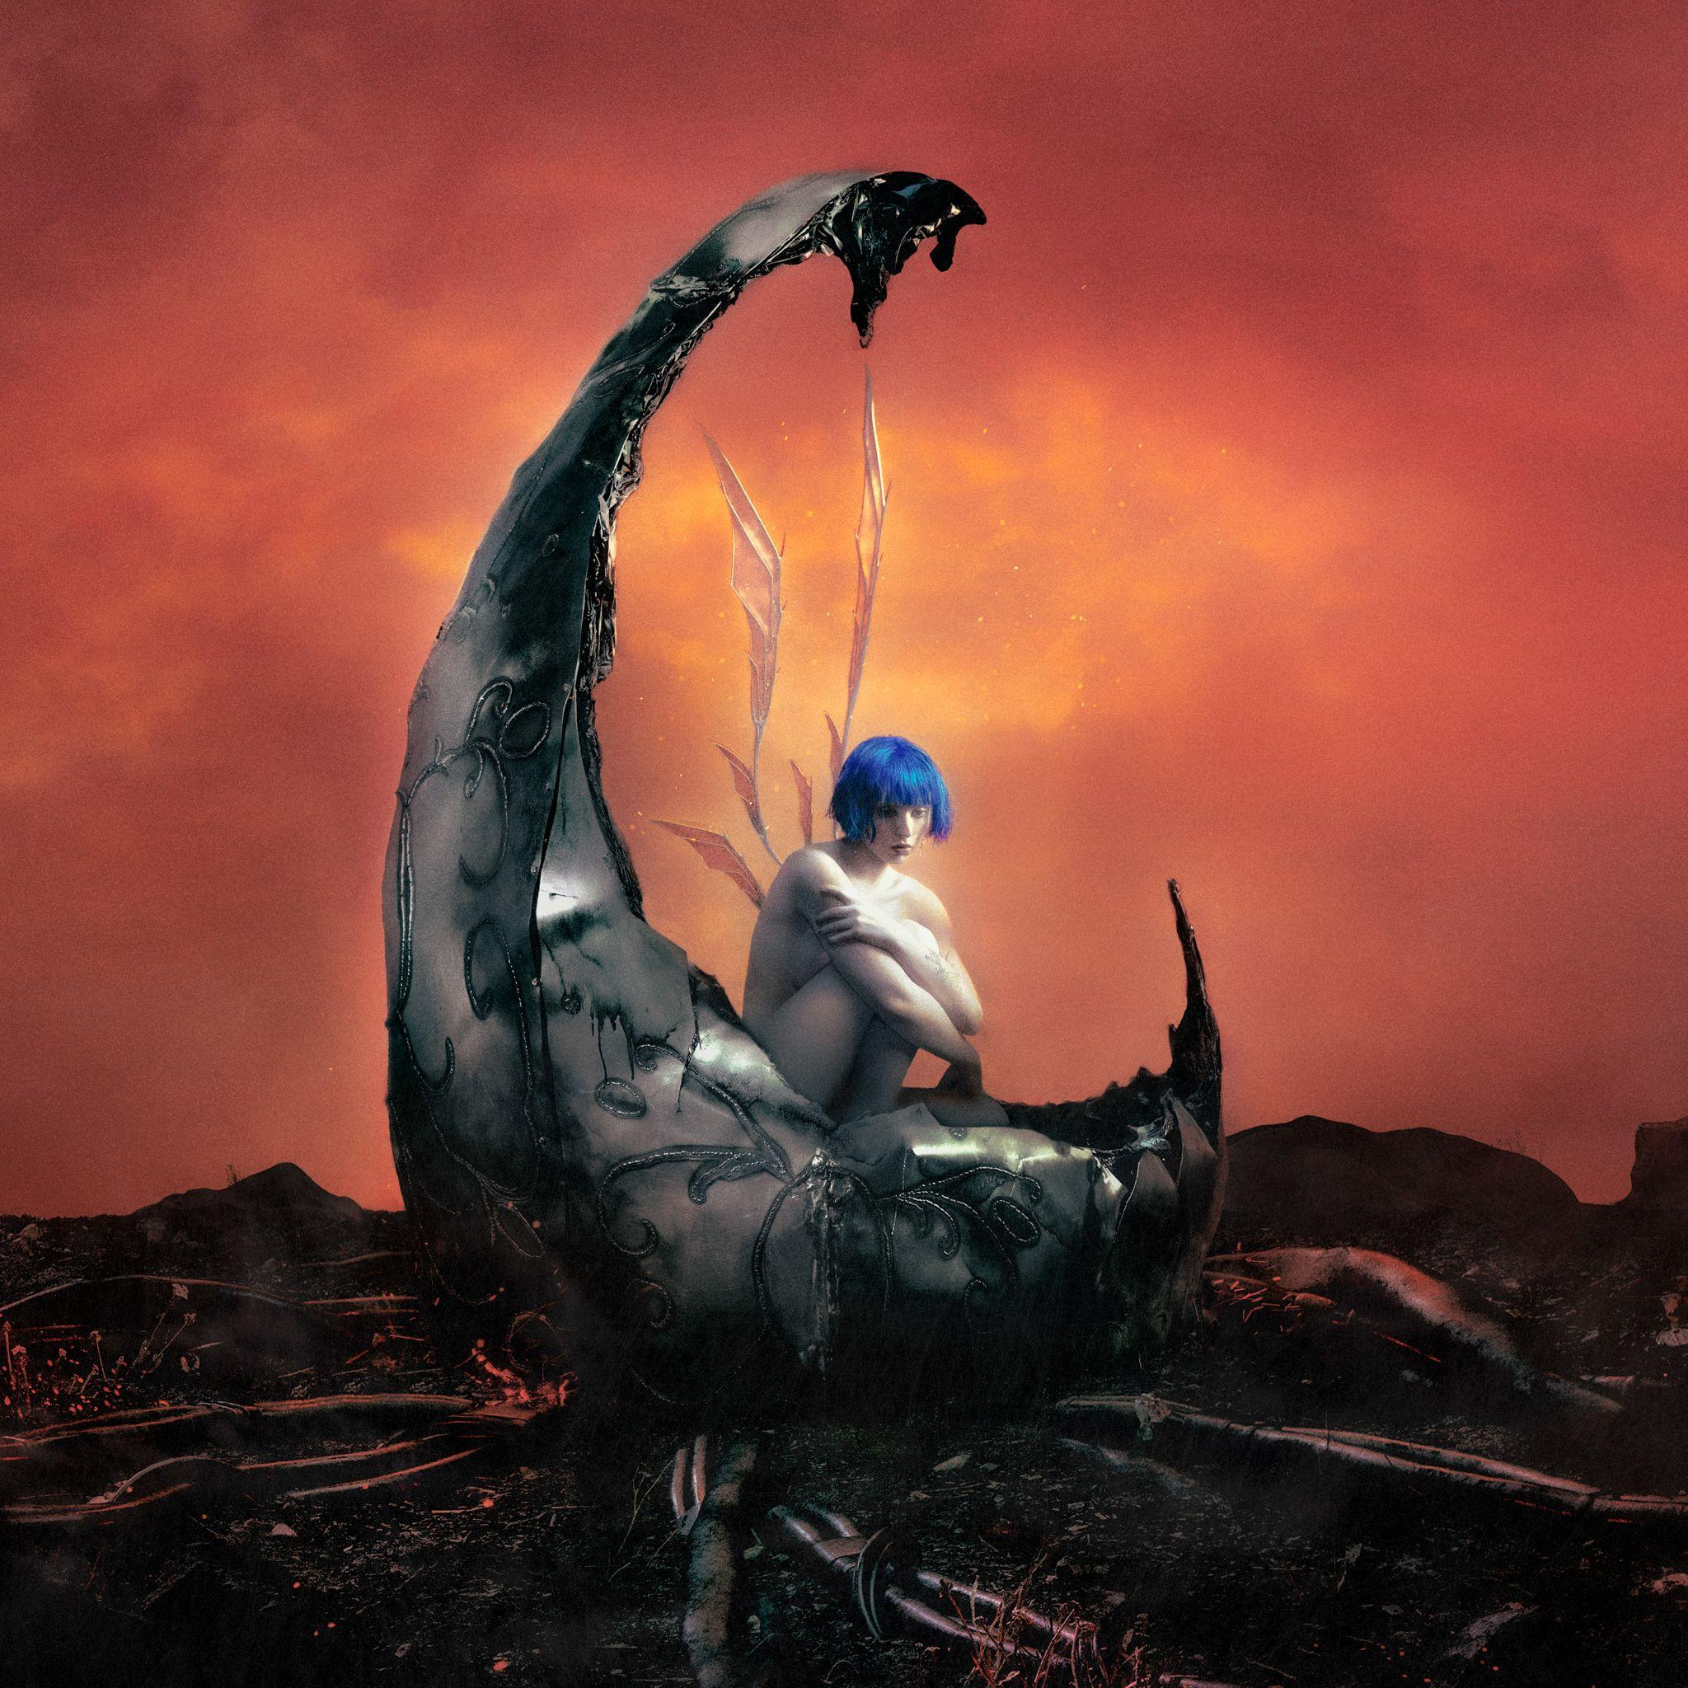
[WEEDKILLER album artwork]

“Ashnikko is one of the most provocative voices in pop right now" - Telegraph
“Rising pop provocateur” - DAZED

Today sees pop disruptor Ashnikko (she/they) announce her hotly anticipated debut album WEEDKILLER, released June 2nd via Parlophone Records. Alongside the album announce, Ashnikko has also released new single Worms (out now) and their forthcoming world tour which goes on sale March 10th. The tour includes 7 shows in the UK, stopping at London, Manchester, Birmingham, Nottingham, Glasgow, Leeds and Bristol.

Stream “Worms” here: https://ashnikko.lnk.to/Worms
Pre-order “Weedkiller” here: https://ashnikko.lnk.to/WEEDKILLER

Debut album WEEDKILLER is a collection of irresistible songs that perfect the bold, genre-blending sound that has defined Ashnikko’s work to date. However, as Ashnikko fans will know, she is known for transporting listeners into her universe and WEEDKILLER is no exception. The WEEDKILLER universe that Ashnikko has created is a dystopian fantasy that tells the story of a fae civilization occupied and destroyed by machines that feed on organic matter where the faerie protagonist seeks revenge by becoming part machine - a poetic commentary on environmental disaster and the rapid evolution of technology. Full of equal parts naked vulnerability and joyful rebellion, WEEDKILLER gives a thundering voice to the oppressed.

Speaking on the announce Ashnikko states "My bioluminescent heart is glowing. My post-apocalyptic fae world is here for you to journey into. My wings have been ripped out, but I’ve built them anew using WEEDKILLER machine parts. I am the one sent here to eliminate you, WEEDKILLER."

In celebration of her debut album announcement, Ashnikko has released new single Worms, which despite its bouncy alt-pop beat has a dark undertone. Along with her recent release You Make Me Sick, these two tracks a new era for Ashnikko as they showcase the breadth of her musical prowess and how they fearlessly shift between genres with ease.

[Worms Artwork]

Since asserting herself within the music industry with acclaimed 2021 mixtape DEMIDEVIL, Ashnikko has made her name as one of today’s most innovative alt-pop artists and the announcement of their debut album is sure to set fans minds racing. The 13-track album sees fears and anxieties whether personal or tyrannical, blown up and then broken down.

Tracklisting

- World Eater
- You Make Me Sick!
- Worms
- Super Soaker (ft. Daniela Lalita)
- Don’t Look At It
- Cheerleader
- Moonlight Magic
- Miss Nectarine
- Chokehold Cherry Python
- WEEDKILLER
- Want It All
- Possession of a Weapon
- Dying Star (ft. Ethel Cain)

Later this year will see Ashnikko take WEEDKILLER on the road as she embarks on her biggest tour to date. To mark the end of DEMIDEVIL era will hit Japan next month before heading to Australia and New Zealand. After a run of festivals this summer The WEEDKILLER tour will hit the US, Europe and UK including headline shows at London’s Alexandra Palace, Brooklyn Mirage in NYC and Élysée Montmartre in Paris. Her live performances are notoriously riotous - with Ashnikko writhing, jumping and thrashing around the stage whilst the crowd follow suit - and in previous years they’ve packed out tents and stages across the world.

Tickets to the WEEDKILLER World Tour are available at ashnikko.com on 10th March 10am local time. Fans who pre-order WEEDKILLER from Ashnikko’s official store before 10am on Wednesday March 8 will get first access to their upcoming UK and European show dates before general sale on Friday March 10th. Full tour routing below…

ASHNIKKO LIVE

JAPAN & AUS
March 24, 2023 - Osaka, Japan - Club Quattro
March 27, 2023 - Tokyo, Japan - Liquid Room
March 29, 2023 - Seoul, South Korea - Watcha Hall
April 01, 2023 - Melbourne, Australia - Northcote Theatre (All Ages early show & 18+ late show)
April 03, 2023 - Adelaide, Australia - Hindley Street Music Hall
April 04, 2023 - Brisbane, Australia - Fortitude Music Hall
April 06, 2023 - Sydney, Australia - Big Top
April 08, 2023 - Auckland, New Zealand - Town Hall

FESTIVALS
April 14, 2023 - Indio, CA - Coachella
April 21, 2023 - Indio, CA - Coachella
June 09, 2023 - Hradec Kralove, Czech Republic - Rock For People
June 16, 2023 - Scheessel, Germany - Hurricane Festival
June 17, 2023 - Neuhausen ob Eck, Germany - Southside Festival
June 18, 2023 - Linz, Austria - Lido Sounds
July 09, 2023 - Glasgow, UK - TRNSMT
August 16, 2023 - Charleville Mézières, France - Cabaret Vert Festival

WEEDKILLER TOUR 2023

US LEG
September 15, 2023 - Minneapolis, MN - The Fillmore
September 16, 2023 - Chicago, IL - Aragon Ballroom
September 18, 2023 - Columbus, OH - KEMBA Live!
September 19, 2023 - Pittsburgh, PA - Stage AE
September 21, 2023 - Toronto, ON - Rebel
September 22, 2023 - Royal Oak, MI - Royal Oak Music Theatre
September 23, 2023 - Cleveland, OH - Agora Theater
September 25, 2023 - Boston, MA - Roadrunner
September 26, 2023 - New York, NY - Brooklyn Mirage
September 28, 2023 - Philadelphia, PA - Skyline Stage at The Mann
September 29, 2023 - Washington, DC - The Anthem
September 30, 2023 - Richmond, VA - The National
October 02, 2023 - Raleigh, NC - The Ritz
October 03, 2023 - Charlotte, NC - The Fillmore
October 05, 2023 - St. Petersburg, FL - Jannus Live
October 06, 2023 - Fort Lauderdale, FL - Revolution Live at the Backyard
October 07, 2023 - Orlando, FL - House of Blues
October 10, 2023 - Atlanta, GA - Coca-Cola Roxy
October 11, 2023 - Nashville, TN - Marathon Music Works
October 13, 2023 - St. Louis, MO - The Pageant
October 14, 2023 - Kansas City, MO - Uptown Theater
October 16, 2023 - Denver, CO - The Mission Ballroom
October 17, 2023 - Salt Lake City, UT - The Complex Rockwell
October 19, 2023 - Vancouver, BC - PNE Forum
October 20, 2023 - Seattle, WA - Showbox SoDo
October 21, 2023 - Portland, OR - Roseland Theater
October 24, 2023 - Oakland, CA - Fox Theater
October 27, 2023 - Phoenix, AZ - The Van Buren

EU & UK LEG
November 19, 2023 - Copenhagen, Denmark - Vega
November 21, 2023 - Warsaw, Poland - Progresja
November 22, 2023 - Berlin, Germany - Huxleys
November 24, 2023 - Paris, France - Elysee Montmartre
November 25, 2023 - Cologne, Germany - Carlswerk Victoria
November 26, 2023 - Amsterdam, Netherlands - Melkweg
November 30, 2023 - London, UK - Alexandra Palace
December 01, 2023 - Manchester, UK - O2 Victoria Warehouse
December 03, 2023 - Birmingham, UK - O2 Institute
December 05, 2023 - Nottingham, UK - Rock City
December 06, 2023 - Glasgow, UK - O2 Academy
December 08, 2023 - Leeds, UK - O2 Academy
December 09, 2023 - Bristol, UK - Marble Factory
December 11, 2023 - Dublin, Ireland - 3Olympia Theatre

For more information, please contact SATELLITE414
Tom.Mehrtens@s-414.com
Claire.Coulton@s-414.com
Mofe.Sey@s-414.com

