GRANDSON RETURNS WITH NEW SINGLE “EULOGY”

LISTEN HERE

ANNOUNCES GLOBAL HEADLINE TOUR
INCLUDING 5 UK SHOWS

TICKETS ON SALE MARCH 3RD AT 10:00AM LOCAL TIME

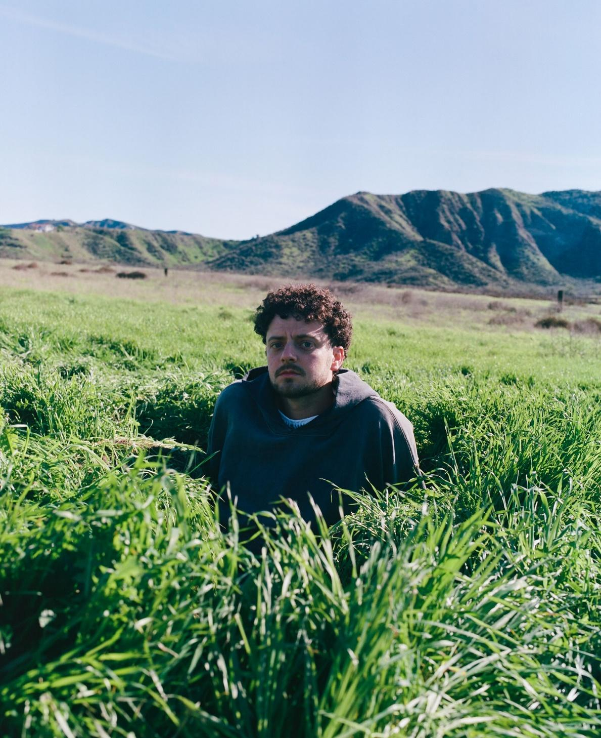
PHOTO CREDIT: ZACHARY BAILEY

FEBRUARY 28, 2023 - Platinum-selling alternative artist grandson has returned with his new single “Eulogy” via Fueled By Ramen. Available today on all streaming platforms, “Eulogy” notably marks grandson’s first new music since 2021.

Speaking about the new song, grandson elaborated, “‘Eulogy’ was written in the aftermath of a bad mushrooms trip this summer, which led me to scrapping my album and admitting to myself and others that I was struggling with fantasies of self harm. It’s easy to feel nihilistic or cynical about the future, and there’s a strange comfort in indulging in the depressing absurdity of day to day life with the only people in the world that understand you.”

On “Eulogy,” grandson leans into a laidback flow punctuated by confessional musings, existential anxiety, and apocalyptic implications. His lyrical introspection gives way to an infectious refrain, “I’m not sure that anything matters at all, it’s the eulogy—for you and me.” The song highlights his inimitable genre alchemy, fusing alternative, hip-hop, and rock seamlessly, and paves the way for additional new music to be released later this year.

“Eulogy” follows the release of grandson’s 2021 single “Drop Dead” featuring GRAMMY-nominated pop superstar Kesha and Travis Barker. The track originally appeared as a solo effort on grandson’s debut LP Death of an Optimist before being reworked. Rolling Stone proclaimed, “‘Drop Dead’ moves effortlessly between atmospheric, pop-leaning verses and a straight-to-the-rafters arena rock chorus.” Additionally, Variety christened it “an empowering call for perseverance in the face of hardship.”

Next up, grandson will embark on a massive global headline tour. The upcoming tour will see grandson visiting the United Kingdom, performing in Leeds, Glasgow, Birmingham, Manchester and London in September 2023. Support for those dates to be announced in the coming weeks [full tour itinerary below].

General on-sale for all tickets goes live on Friday, March 3rd at 10am local time. For tickets and more information on the upcoming dates, visit www.grandsonmusic.com/tour.

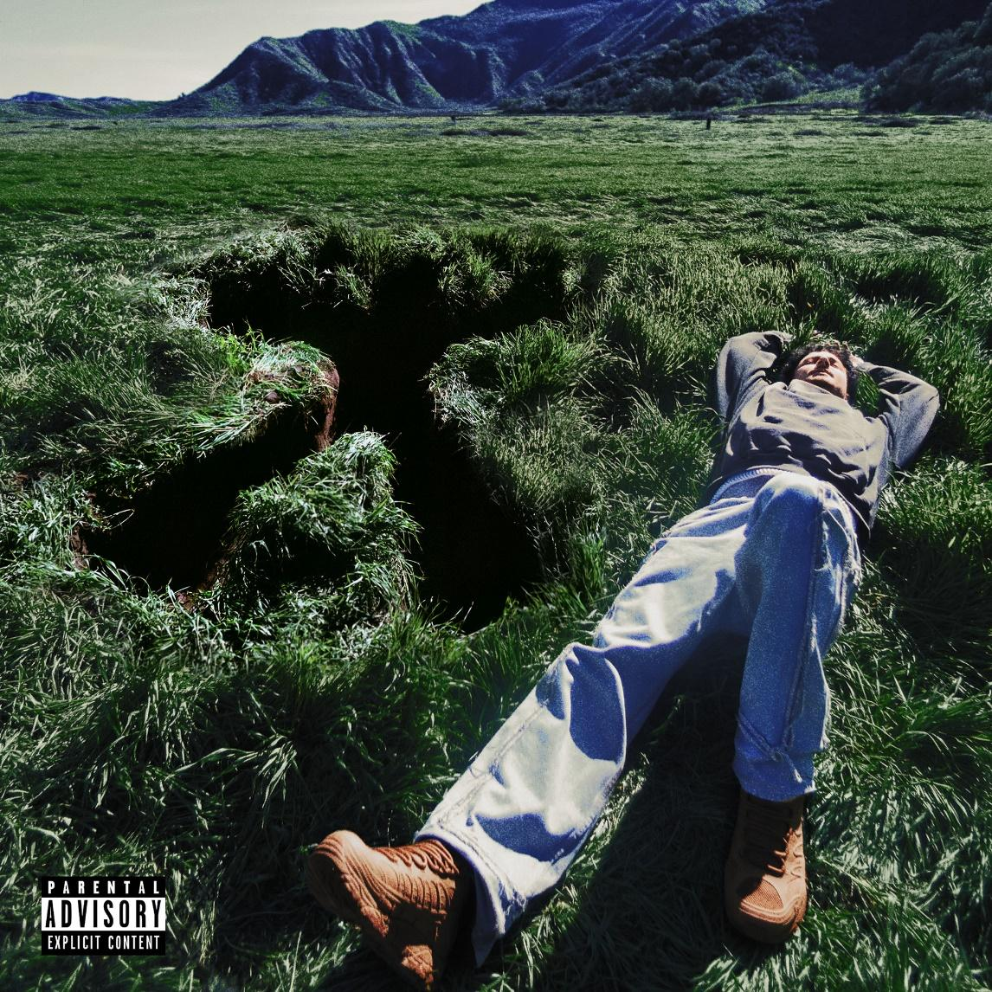
“EULOGY” – SINGLE ART

2023 UK HEADLINE DATES
September 8th – Leeds University Stylus – Leeds, United Kingdom
September 9th – SWG3 Warehouse – Glasgow, United Kingdom
September 10th – O2 Institute2 – Birmingham, United Kingdom
September 13th – Academy 2 – Manchester, United Kingdom
September 15th – Electric Ballroom – London, United Kingdom

FULL 2023 GLOBAL HEADLINE TOUR

May 12th – House Of Blues – San Diego, California #
May 14th – Sunshine Theater – Albuquerque, New Mexico #
May 16th – Warehouse Live – Houston, Texas #
May 17th – Tech Port Center – San Antonio, Texas #
May 18th – House Of Blues – Dallas, Texas #
May 19th – Joy Theater – New Orleans, Louisiana #
May 21st – Welcome to Rockville Festival – Daytona Beach, Florida @
May 22nd – The Ritz Ybor – Tampa, Florida #
May 23rd – The Masquerade (Heaven) – Atlanta, Georgia #
May 24th – Skydeck – Nashville, Tennessee #
May 26th – The National – Richmond, Virginia #
May 27th – The Fillmore – Charlotte, North Carolina #
May 28th – Sonic Temple Festival – Columbus, Ohio @
May 29th – The Fillmore – Silver Spring, Maryland #
May 31st – House Of Blues – Boston, Massachusetts #
June 2nd – Toads – New Haven, Connecticut #
June 3rd – Webster Hall – New York, New York *
June 4th – Franklin Music Hall – Philadelphia, Pennsylvania *
June 5th – Roxian Theatre – Pittsburgh, Pennsylvania *
June 6th – Egyptian Room – Indianapolis, Indiana *
June 9th – St. Andrews Hall – Detroit, Michigan *
June 11th – House Of Blues – Chicago, Illinois *
June 12th – Palace Theatre – St. Paul, Minnesota *
June 13th – The Rave – Milwaukee, Wisconsin *
June 15th – The Admiral – Omaha, Nebraska *
June 16th – The Factory – St. Louis, Missouri *
June 17th – Boulevardia Festival – Kansas City, Missouri @
June 19th – Mission Ballroom – Denver, Colorado *
June 20th – The Complex – Salt Lake City, Utah *
June 22nd – Revolution Concert House – Boise, Idaho *
June 23rd – Showbox SoDo – Seattle, Washington *
June 24th – Roseland Theatre – Portland, Oregon *
June 26th – Warfield Theatre – San Francisco, California *
June 27th – The Wiltern – Los Angeles, California *
June 29th – Van Buren – Phoenix, Arizona *
July 1st – Diamond Ballroom – Oklahoma City, Oklahoma ^
July 2nd – Growlers – Memphis, Tennessee ^
July 3rd – Bogarts – Cincinnati, Ohio ^
July 5th – Empire Live Underground – Albany, New York ^
July 9th – Aura – Portland, Maine ^
July 10th – The Met – Pawtucket, Rhode Island ^
July 11th – Wally’s – Hampton Beach, New Hampshire ^
July 17th – Corona Theatre – Montreal, Quebec ^^
July 19th – History – Toronto, Ontario ^^
July 21st – The Bronson Centre – Ottawa, Ontario
July 22nd – London Music Hall – London, Ontario ^^
July 24th – Guelph Concert Theatre – Guelph, Ontario ^^
July 27th – The Park Theatre – Winnipeg, Manitoba ^^
July 28th – Roxy – Saskatoon, Saskatchewan ^^
July 29th – The Palace – Calgary, Alberta ^^
July 31st – Union Hall – Edmonton, Alberta ^^
August 2nd – Harbor Event Centre – Vancouver, British Columbia ^^
August 3rd – Capital Ballroom – Victoria, British Columbia ^^
August 11th – Foro Indie Rocks – Mexico City, Mexico
September 7th – Opium Room – Dublin, Ireland
September 8th – Leeds University Stylus – Leeds, United Kingdom
September 9th – SWG3 Warehouse – Glasgow, United Kingdom
September 10th – O2 Institute2 – Birmingham, United Kingdom
September 13th – Academy 2 – Manchester, United Kingdom
September 15th – Electric Ballroom – London, United Kingdom
September 17th – den Atelier – Luxembourg City, Luxembourg
September 19th – Trabendo – Paris, France
September 20th – Carlswerk Victoria – Cologne, Germany
September 23rd – Backstage Werk – Munich, Germany
September 24th – Astra Kulturhaus – Berlin, Germany
September 26th – Proxima – Warsaw, Poland
September 27th – Haus Auensee – Leipzig, Germany
September 28th – Roxy – Prague, Czech Republic
September 29th – Dürer Kurt – Budapest, Hungary
September 30th – SiMM City – Vienna, Austria
October 3rd – Magazzini Generali – Milan, Italy
October 4th – Dynamo Saal – Zürich, Switzerland
October 5th – ZOOM – Frankfurt, Germany
October 6th – Melkweg Max – Amsterdam, Netherlands
October 8th – Trix – Antwerp, Belgium
October 10th – Lille Vega – Copenhagen, Denmark
October 11th – John Dee – Oslo, Norway
October 12th – Debaser – Stockholm, Sweden
October 13th – Pustervik – Gothenburg, Sweden
October 15th – Apollo Live Club – Helsinki, Finland
October 17th – Helitehas – Tallinn, Estonia
October 18th – Kablys – Vilnius, Lithuania

K.Flay (Direct Support May 12th – June 29th)
* Jack Kays as 1 of 3
# TBD as 1 of 3
^ No Love For The Middle Child & grandson only
^^ Monowhales as Support
@ Festival Date

ABOUT GRANDSON
grandson molds genres, sculpting rock, hip-hop, and electronic into a vision of alternative you’ve never quite heard, seen, or felt before. Having amassed a staggering 1 billion streams and counting, the platinum-certified Canadian / American maverick flouts boundaries only to achieve stylistic unity with alacrity. He infiltrated culture as a sonic insurgent with a pair of EPs—a modern tragedy Vol. 1-2—and the platinum single “Blood // Water.” In 2020, he continued to engage with his epically enigmatic full-length debut, Death of An Optimist. He’s the rare outlier who can appear with Senator Bernie Sanders on a livestream and contribute two songs to James Gunn’s The Suicide Squad Original Motion Picture Soundtrack, namely “Oh No!!!” [with VIC MENSA & Masked Wolf] and “Rain” [with Jessie Reyez]—also remixed by star Idris Elba. Meanwhile, he’s impressively collaborated with everyone from Mike Shinoda of Linkin Park and Steve Aoki to Travis Barker, Kesha, K. Flay, X Ambassadors, Whethan, Two Feet, and DE’WAYNE, to name a few. Speaking of high-powered collabs, he impressively joined forces with Tom Morello for “Hold The Line” and performed the latter on The Tonight Show Starring Jimmy Fallon with the legendary guitarist. In addition, he has incited the applause of Rolling Stone, Variety, Billboard and many more as he continues to quietly reshape alternative with more music and surprises in 2023.

CONNECT WITH GRANDSON:
WEBSITE / INSTAGRAM / TIKTOK / FACEBOOK / TWITTER / SPOTIFY / APPLE MUSIC / YOUTUBE

