WUNDERHORSE ANNOUNCE BIGGEST
UK/IRE SHOWS YET FOR AUTUMN 2023

TICKETS AVAILABLE HERE FRIDAY MARCH 10TH

LISTEN TO ‘PURPLE’ HERE

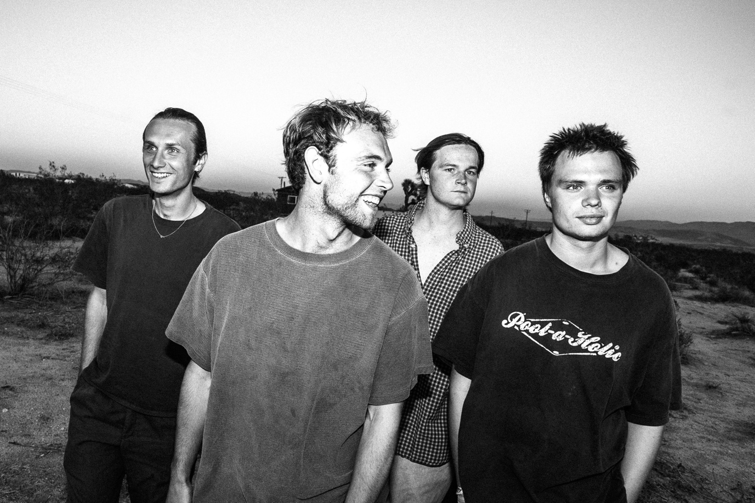
Photo credit: Gabe Drechsler (hi-res here)

Wunderhorse are excited to announce their biggest headline shows to date, including a stop at London’s O2 Forum Kentish Town on 1st November.

This run of live performances punctuate a breakout campaign which has seen the band touring with the likes of Fontaines D.C, Pixies, Sam Fender and Foals, whilst selling out their own headline slots along the way.

‘Purple’ - the latest offering from Wunderhorse’ acclaimed debut album, Cub - currently sits on rotation at Radio One, Radio X and Absolute Radio.

LISTEN TO DEBUT ALBUM CUB HERE

Cub was born from the ashes of singer Jacob Slater’s much-hyped but ultimately ill-fated teenage punk outfit Dead Pretties. After calling it a day on the anarchic trio, Slater relocated to the Cornish coast in search of a more peaceful existence in which he could concentrate on his own wellbeing and indulge in his passion for surfing.

This clean coastal air and slower pace of life quickly paid dividends, allowing Jacob to grow as an artist and apply himself to building an introspective and cerebral songbook, without losing any of the bite from his previous endeavour.

From the tightly-coiled claustrophobia of ‘Teal’, to the barnstorming blues-rock of ‘Leader of the Pack’, via to a bleary-eyed nostalgia of ‘17’, Cub’s tracks are the fruits of maturity: a testament to exiting the road to self-destruction, gaining perspective, and realising the potential of an abundant songwriting talent.

TICKETS AVAILABLE HERE
9AM 10th MARCH

PRESALE AVAILABLE
9AM 8TH MARCH

WUNDERHORSE 2023 TOUR DATES
25th October – Bristol, SWX
27th October – Manchester, O2 Ritz
28th October – Dublin, Button Factory
29th October – Glasgow, SWG3
31st October - Birmingham, O2 Academy 2
1st November - London, O2 Forum Kentish Town

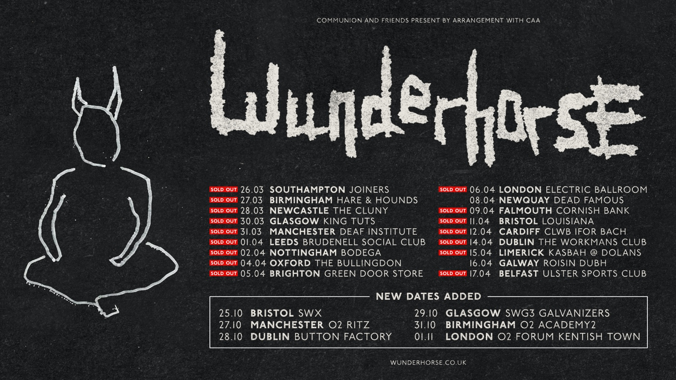

Wunderhorse online
Instagram | Twitter | Facebook | YouTube

