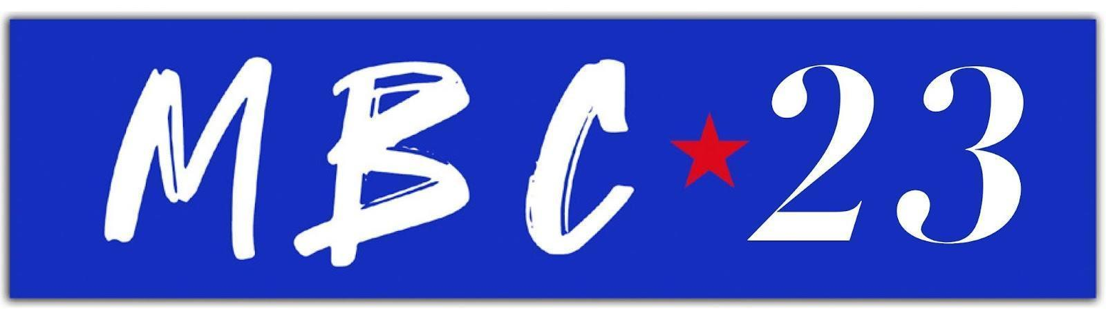
Margo Price Joins Forces With Sierra Ferrell
To Reimagine “Change of Heart”: LISTEN HERE

New Rendition of Chart-Topping Single Follows Recent Collaborations With Sharon Van Etten, Lucius & More Featured On Strays

Announces Special Headline Date At London’s Lafayette On August 25th
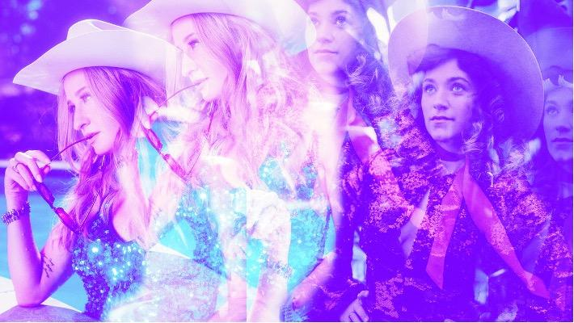
(Photo credit: Margo Price / Bobbi Rich + Sierra Ferrell / Alysse Gafkjen)

"Brilliantly rattles through country, psych and Patti Smith-style poetic rock’n’roll...powerful lyrical gut-punches" - The Guardian, ★★★★

"Sonically brave and lyrically obstinate, a rare delight that stands out from its counterparts" - NME, ★★★★

"It’s her weirdest and wildest record yet, but also her wisest" - UNCUT

"This is an album to cherish" - CLASH

Margo Price has joined forces with Sierra Ferrell to release a brand new rendition of her Strays standout “Change of Heart,” which recently reigned #1 for 14 consecutive weeks on the Americana chart. Margo has also announced a special, intimate date at London’s Lafayette on Friday August 25th. The show comes alongside her recently announced appearance at The Long Road Festival at Stanford Hall in Leicestershire.

The single marks the first-ever collaboration between two of Nashville’s most shapeshifting singers and songwriters, who together transform the track from a turbulent eruption of psych rock into a stripped-back, but swift arrangement of spellbinding vocals, a gently stomping acoustic guitar, and haunting lines of fiddle.

Listen to “Change of Heart” (feat. Sierra Ferrell) via Loma Vista Recordings, available on DSPs as a three-track EP alongside Strays highlights “Radio” (feat. Sharon Van Etten) & “Anytime You Call” (feat Lucius)

On working with Sierra Ferrell, and celebrating friends, fellow artists and collaborators during Women’s History Month, Margo Price says, “I’m real excited to share this stripped down take on 'Change of Heart' featuring Sierra Ferrell. Sierra is one of my favorite new voices in music and I loved getting to work with her on this acoustic version of the song.” She continues “I love to lift up other women in the genre when I see somebody putting out great art. In an industry that tries to drive us apart, it’s freeing to break down those barriers and say, “there is room for everyone.”

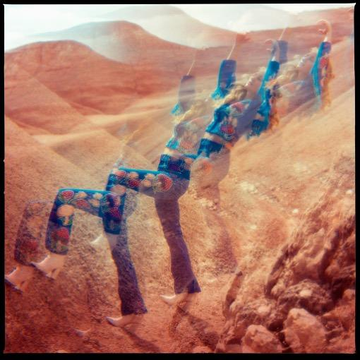
“Change of Heart” (feat. Sierra Ferrell) Single Art

Following the release of Strays – a freedom-filled, mushroom-fueled, Jonathan Wilson-produced opus – Margo Price has showcased songs like “Change of Heart” and “Radio” on The Late Late Show with James Corden, CBS Mornings and a national headline tour that just wrapped with a triumphant return to the Ryman Auditorium. This week, Price heads to Texas to discuss Strays and her memoir Maybe We’ll Make It during a keynote conversation at SXSW, in addition to taping an episode for Season 49 of Austin City Limits, and more.

As well as the announced UK dates, Margo Price will also return to the road for the first of many amphitheater and arena dates with Chris Stapleton, as well as shows with Tyler Childers, appearances at Long Story Short: Willie Nelson 90 and numerous summer festivals. Find the full list here.

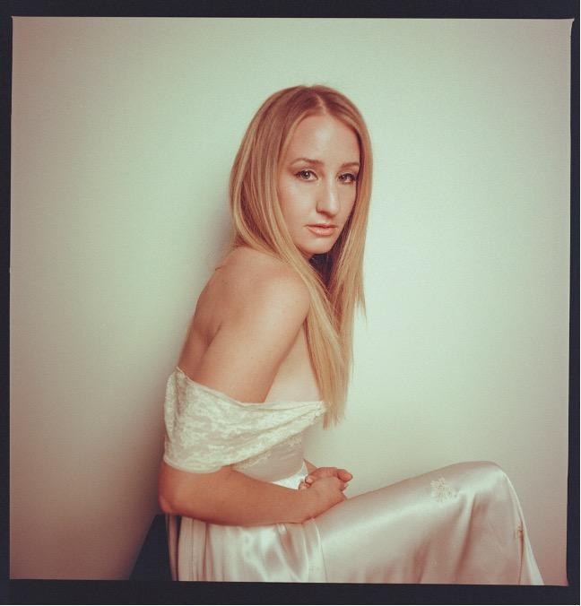
Photo by Alysse Gafkjen

Follow Margo Price
Official Site l Facebook l Twitter l Instagram l YouTube

