JIM BOB
ANNOUNCES LONDON DATE TO UK TOUR
TICKETS ON SALE AT 9AM ON FRIDAY 24th MARCH AT 9AM HERE

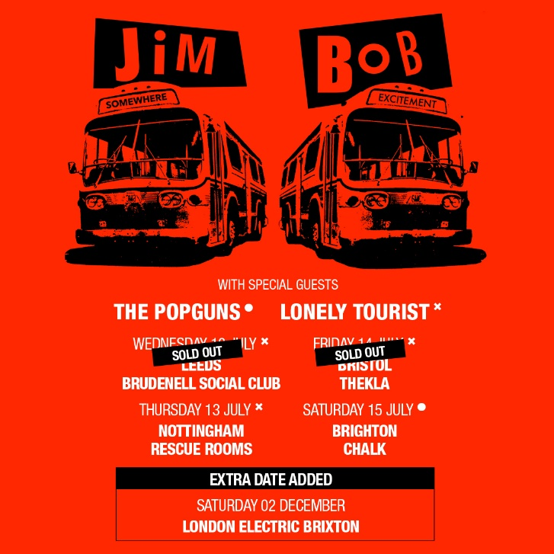

With multiple dates sold out, former Carter The Unstoppable Sex Machine singer and acclaimed solo artist Jim Bob has today announced an extra date to his upcoming UK tour at London’s Electric Brixton on Saturday 2nd December 2023.

These full band gigs will see Jim Bob performing songs from his last two top 40 albums, plus solo favourites from his solo career, Carter classics and songs from his upcoming new album. Jim Bob said:

'Forgive me for getting all seasonal and Christmassy on you when we’re still a week away from the official start of summer and there are still Easter eggs on the shelves of Sainsbury’s and Lidl but I can’t for the life of me think of anything more traditional than a winter gig in Brixton. All those legendary Carter nights at the Academy – November 9 1991 and Decembers 21 and 22 in 1992, or how about that amazeballs night on the 20th November 2021 when I returned to The Fridge only to discover it had changed its name to The Electric. So why not join me back at the Electric in Brixton this year, on Saturday 2 December, for a night I can already sense is going to be off the charts incredible.'
On his upcoming new album Jim Bob continued:

“There will be details on that in the next couple of weeks. Keep your ears to the ground or maybe just look online every now and then.”

Tickets for the brand new London show go on sale Friday 24th March at 9am UK time via http://gigst.rs/JimBob

JIM BOB UK TOUR
WEDNESDAY 12 JULY 2023 LEEDS BRUDENELL - SOLD OUT
THURSDAY 13 JULY 2023 NOTTINGHAM RESCUE ROOMS
FRIDAY 14 JULY 2023 BRISTOL THEKLA - SOLD OUT
SATURDAY 15 JULY 2023 BRIGHTON CHALK
SATURDAY 02 DECEMBER 2023 LONDON ELECTRIC BRIXTON– NEW DATE ADDED

WEBSITE TWITTER FACEBOOK INSTAGRAM YOUTUBE

