OCEAN ALLEY
ANNOUNCE RETURN TO THE UK THIS SUMMER
UK & EUROPE TOUR TICKETS ON SALE 10 AM FRIDAY

WATCH ‘WEST COAST’ MUSIC VIDEO HERE

ALBUM LOW ALTITUDE LIVING
OUT NOW

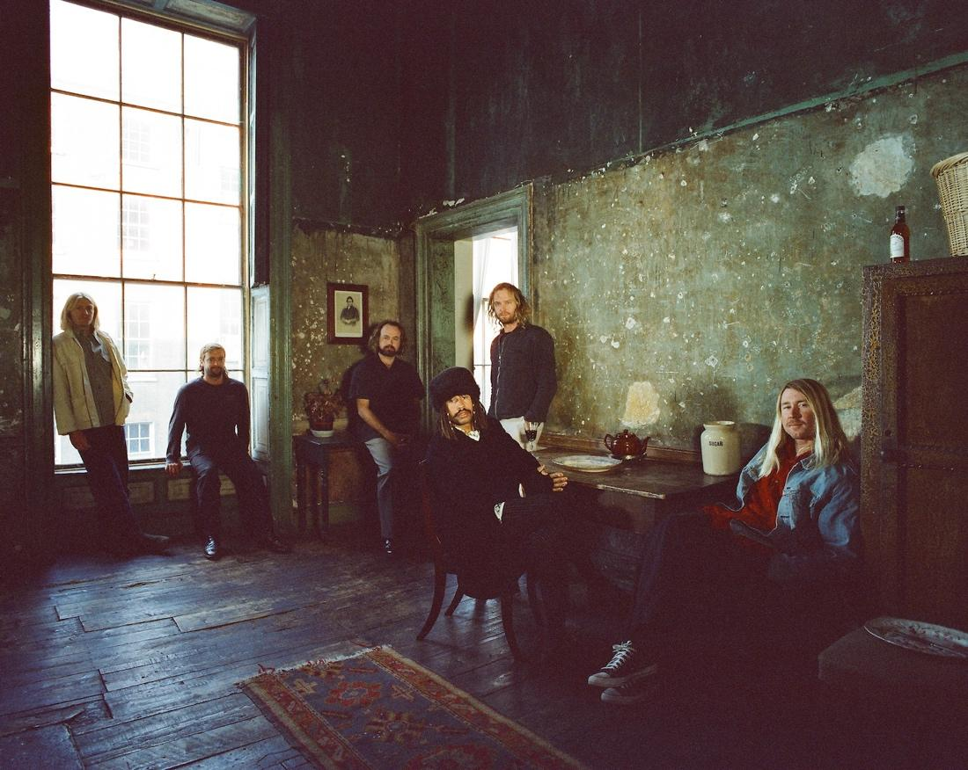
CREDIT: Kane Lehanneur

A year on from their sold-out European tour last year, Ocean Alley today announce a triumphant return this summer with 12 live dates across the UK, Ireland and Europe this June. Beginning in Liverpool on 12th June, the Australian six piece will also be visiting Bristol, Manchester and Glasgow, amongst other cities, before finishing off at London’s iconic The Troxy, just over a year after they sold out The Roundhouse. They also played a memorable underplay show at Lafayette, London in August, which sold out in minutes. Tickets go on sale at 10am this Friday 31st March.

To celebrate their upcoming tour, the band recently shared their new video ‘West Coast’, taken from their album Low Altitude Living, released last fall. Full tour details below.

Speaking on the newly announced shows, the band said:“We are super excited to get back over to the UK in a few months for our biggest shows to date! We have a set list full of songs we haven’t played live before, so we’re pumped!”

Watch Ocean Alley ‘West Coast’
Speaking on the video Baden Donegal (vocals, guitar) explains, “The concept of the West Coast music video was to recreate the GTA game. The song sounds like it’s apart of the GTA soundtrack, so we thought it would match up well. Mimicking the video game style movements of NPC’s was a challenge but it was fun to have everyone involved in the film clip and give their acting skills a crack. We shot the clip in New Zealand and on the streets of Sydney.”

Ocean Alley are one of Australia’s most exciting musical exports. Low Altitude Living debuted #3 on the ARIA charts, #1 ARIA Vinyl and #5 on the New Zealand album chart and has over 15 million global streams. Last year alone saw the band perform 65 shows around the world and sell a cumulative 75,000+ tickets across their headline shows. Operating as a proudly independent band, their output has always been underscored by a refreshingly chilled authenticity and relatability that has seen them achieve more than 500 million catalogue streams.

Low Altitude Living follows the success of 2020’s critically acclaimed Lonely Diamond which also debuted at #1 on the ARIA Vinyl Chart and #3 on the Album Chart. The band have achieved 1x Double Platinum and 5x Gold-certified singles across Australia and New Zealand, as well as Gold certification on their 2018 breakthrough Chiaroscuro.

Low Altitude Living is available to stream and purchase now.

OCEAN ALLEY UK & EUROPE TOUR DATES 2023

Mon Jun 12 - 02 Academy, Liverpool, UK
Tue Jun 13 - 02 Academy, Bournemouth, UK
Thu Jun 15 - The Lost Gardens, Port Elliot, UK
Fri Jun 16 - St Agnes Summer Sessions, St Agnes UK
Sun Jun 18 - Vicar Street, Dublin, IRE
Tue Jun 20 - 02 Academy, Bristol, UK
Thu Jun 22 - De La Warr Pavillion, Bexhill, UK
Fri Jun 23 - Kantine, Cologne, GER
Sun Jun 25 - Bostheater, Amsterdam, NED
Tue Jun 27 - Albert Hall, Manchester, UK
Wed Jun 28 - SWG3 TV Studio, Glasgow, UK
Fri Jun 30 - The Troxy, London, UK

Follow Ocean Alley:
oceanalley.com.au
facebook.com/oceanalleyband
twitter.com/oceanalleyau
tiktok.com/@oceanalleyband
@oceanalleyband

For more information please contact Charlie Brun at DawBell
charlie.brun@dawbell.com

