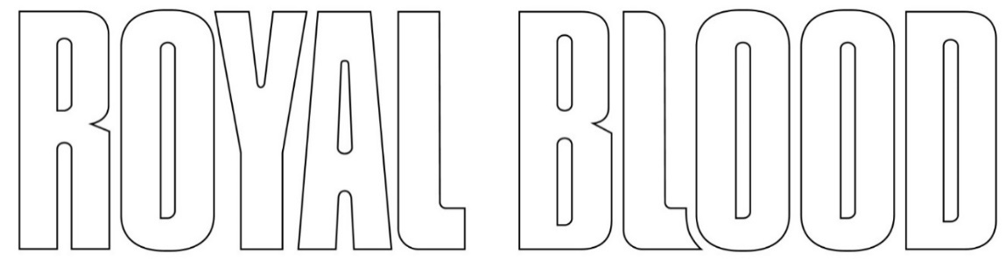

ANNOUNCE UNDERPLAY SHOWS IN NOTTINGHAM AND NEWCASTLE

SUMMER TOUR ALSO INCLUDES HUGE BRIGHTON BEACH HEADLINE SHOW, STADIUM GIGS WITH MUSE, AND FESTIVAL HEADLINE SETS

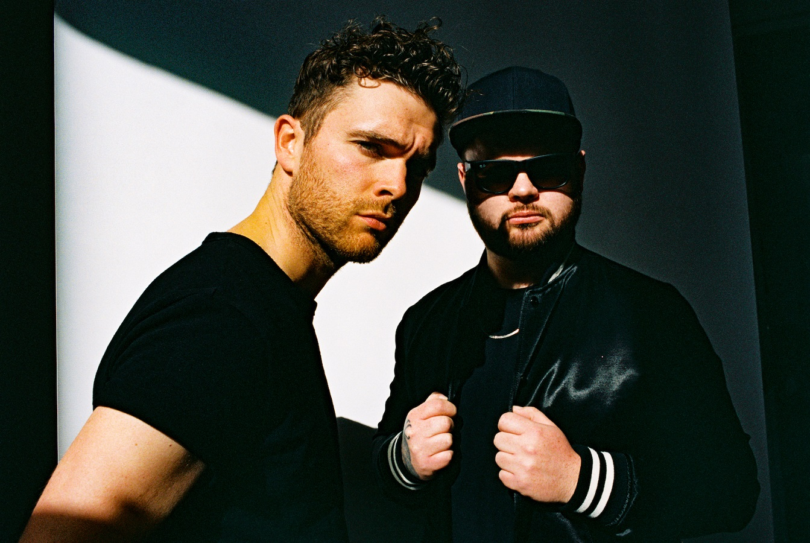

Royal Blood add to a big summer of touring by announcing details of two underplay headline shows at Nottingham Rock City (May 26th) and Newcastle’s O2 City Hall (June 21st). Tickets for both shows will go on sale HERE from 10am next Thursday, April 6th.

The new dates build upon a summer schedule which is packed with major outdoor shows. A huge homecoming On The Beach show in Brighton is sure to be a career highlight for the duo, Mike Kerr and Ben Thatcher, while they are also confirmed to play three stadium shows as special guests to Muse. In addition, Royal Blood are set to be one of the defining bands of 2023’s festival circuit, with headline sets at Truck, Kendal Calling and Y NOT? as well as prime billing at both Glastonbury and TRNSMT.

In addition to the UK dates, listed below, Royal Blood will tour Europe throughout the summer with a mix of intimate headline shows and further gigs as special guests to Muse. They’re also confirmed to play two major North American festivals: Sea.Hear.Now and Louder Than Life. Please see their website for a full list of international shows and ticket details.

MAY
26th – Nottingham, Rock City (HEADLINE SHOW)
27th – Plymouth, Home Park (with Muse)

JUNE
20th – Huddersfield, John Smith’s Stadium (with Muse)
21st – Newcastle, O2 City Hall (HEADLINE SHOW)
21st-25th - Glastonbury
25th – Milton Keynes Bowl (with Muse)

JULY
9th- TRNSMT
23rd – Truck Festival (HEADLINERS)
27th-30th – Kendal Calling (HEADLINERS)
28th-30th – Y NOT? Festival (HEADLINERS)
29th – Brighton Beach (HEADLINE SHOW)

Since debuting in 2013 with the fan favourite single ‘Out of the Black’, all three of Royal Blood’s albums have fired to #1 in the UK: their self-titled debut (2014), ‘How Did We Get So Dark?’ (2017) and ‘Typhoons’ (2021). The duo have won a host of awards, including the BRIT Award for Best British Group as well as further honours at the NME and Kerrang! Awards. Their biggest UK headline show to date was at London’s 20,000 capacity O2, and they have also played shows with Foo Fighters, Arctic Monkeys and Queens of the Stone Age.

Follow Royal Blood:
Website | Spotify | Apple Music | YouTube | Facebook | Instagram | Twitter | TikTok

For more information please contact:
Print – andy.prevezer@gmail.com / Online – morad@mokhopr.com

