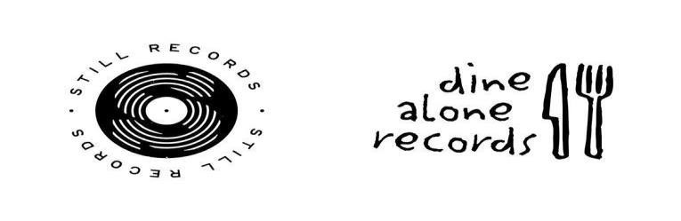

CITY AND COLOUR

MAJOR HEADLINE UK TOUR ANNOUNCED
INCLUDING DATE AT LONDON O2 SHEPHERD’S BUSH EMPIRE Tickets on sale Friday 21 April at 10AM HERE

NEW ALBUM THE LOVE STILL HELD ME NEAR OUT NOW

Download hi-res version here | Photo Credit: Vanessa Heins

Following the release of 7th studio album, The Love Still Held Me Near, acclaimed singer, songwriter and performer Dallas Green AKA City and Colour has announced a major headline UK tour for this autumn culminating at London’s O2 Shepherd’s Bush Empire on Thursday 2nd November.
Over the course of seven studio albums, Dallas Green has compiled a canon ripe with songs born of adoration and devotion amassing a legion of fans worldwide and garnering him 4 JUNOs, including 2 Songwriter of the Year awards, plus 1 Triple Platinum, 2 Double Platinum, 1 Platinum, and 1 Gold certification at home in Canada. Alongside these accomplishments, Green has been awarded Platinum-certification for all four of Alexisonfire’s full-length records.

City and Colour’s last studio album A Pill For Loneliness - released on Green’s Still Records, an imprint of Dine
Alone Records - debuted at #1 on the Billboard Canadian Albums Chart, his 4th consecutive chart-topper in Canada. His previous #1 LP If I Should Go Before You made serious waves internationally debuting at #16 on the U.S. Billboard 200 Chart and #5 in Australia where Green’s LP Little Hell was certified GOLD. In 2014, Green collaborated with international superstar Alecia Moore (aka P!nk) on a new project titled You+Me. The duo’s acclaimed Platinum-certified first record, rose ave., debuted at #4 on the U.S. Top 200 Chart, #1 in Canada, #2 in Australia culminating in memorable performances on The Ellen Show and Jimmy Kimmel Live.
City and Colour’s new album The Love Still Held Me Near finds the songwriter revealing more of himself amidst new textures, arrangements and soundscapes not previously heard on City and Colour albums. While it was born out of navigating a trying time, it is an album of hope, redemption and inspiration, taking a trip from the emotional depths through the other side and finding a way to, as the closing track says, "Begin Again”.

City and Colour’s new live dates follows the acclaimed return of Alexisonfire last year who released their first studio album in 13 years and saw a massive sold-out tour across the UK & Mainland Europe. Tickets for City and Colour 2023 go on sale Friday 21st April at 10am via https://gigst.rs/CAC.

CITY AND COLOUR
Fri 27 Oct 2023 Bristol - O2 Academy
Sun 29 Oct 2023 Birmingham - O2 Institute
Mon 30 Oct 2023 Manchester - Albert Hall
Tue 31 Oct 2023 Glasgow - Barrowland
Thu 02 Nov 2023 London - O2 Shepherd’s Bush Empire

Praise for The Love Still Held Me Near

“This elegy from the Alexisonfire guitarist and singer’s solo journey will leave you with goosebumps”- The I Newspaper

“Despite dealing with some enormous losses, ‘The Love Still Held Me Near’ shines with optimism …That perspective allows this album to become City and Colour’s most accomplished yet.” - Upset Magazine

"The Love Still Held Me Near finds Green at his most personal and raw, accompanied by textures and arrangements that have gone previously unexplored in his solo work." - Exclaim!

“He performs as City and Colour to offer his most vulnerable, delicate and breathtaking music…” - Alternative Press

“A stirring dose of soul-searching catharsis…” - Louder Sound

City and Colour: Website | Twitter | Facebook |
Instagram | Still Records | Dine Alone Records

