SEAL
ANNOUNCES 30TH ANNIVERSARY UK TOUR
CELEBRATING HIS CLASSIC ALBUMS SEAL I AND SEAL II

PERFORMING HIS GREATEST HITS LIVE IN CONCERT

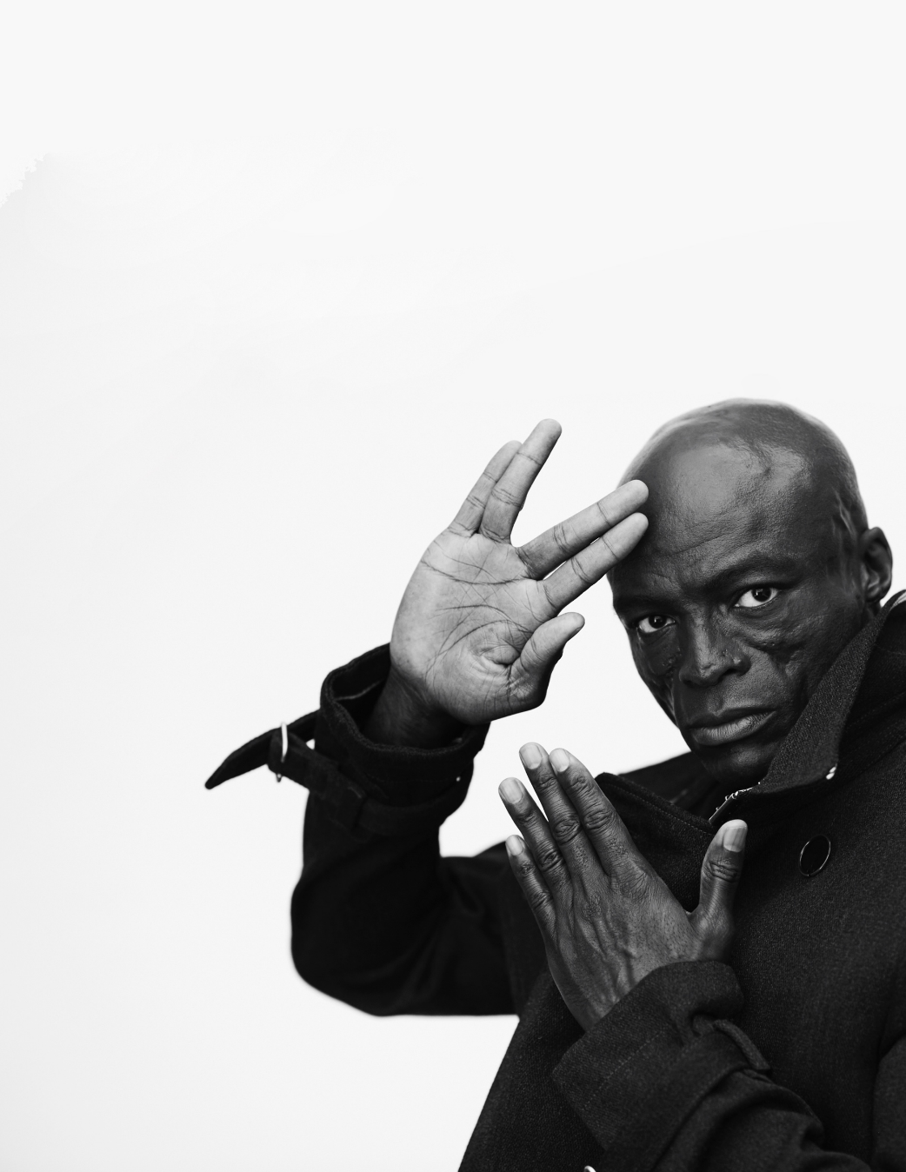

GRAMMY® award-winning singer-songwriter Seal has today announced a very special 30th anniversary UK tour for September 2023.

Celebrating three decades of his landmark self-titled debut album Seal (1991) and eponymous follow-up Seal II (1994), he’ll be performing his greatest hits live in concert across some of the country’s most iconic venues. Expect to hear all of the classic songs from his incredible repertoire including “Crazy,” “Future Love Paradise,” “Killer,” and “Kiss From A Rose.” The tour will also see Seal team up with long-time producer and collaborator Trevor Horn, who will take on the role of musical director for the shows.

Wielding one of the most identifiable voices of all-time, Seal has left an indelible imprint on pop, R&B, soul, and dance music. Along the way, he has sold over 30 million albums worldwide, generated in excess of 1 billion streams, and garnered four GRAMMY® Awards, three BRIT Awards, Two Ivor Novello Awards, and one MTV VMA. A versatile and vital force throughout popular culture his music has also been celebrated with covers by Alanis Morissette, Bastille, and George Michael, to name a few. Along the way, he has collaborated with everyone from Jeff Beck, Joni Mitchell, and Santana to P!nk, John Legend, and Gallant. However, Seal’s voice resounds louder than ever with more music in 2023 and beyond.

Currently on the US leg of his worldwide tour, Seal will be hitting the UK this September for a run of unforgettable live shows. Tickets go on sale 9:30am on Friday 19th May and will be available from www.gigsandtours.com / www.ticketmaster.co.uk

UK LIVES DATES 2023

Tue 12 September Liverpool Philharmonic Hall
Wed 13 September Sheffield City Hall
Thu 14 September Wolverhampton The Civic at The Halls
Sat 16 September Manchester Opera House
Sun 17 September London Palladium

Connect with Seal
Website / Facebook / Twitter / Instagram

