**Friendly Fires announce 15th Year Anniversary UK Tour Of ‘Friendly Fires’ Album**

**Limited-edition vinyl reissues of ‘Friendly Fires’ and ‘Paris’ coming 8th September on XL**

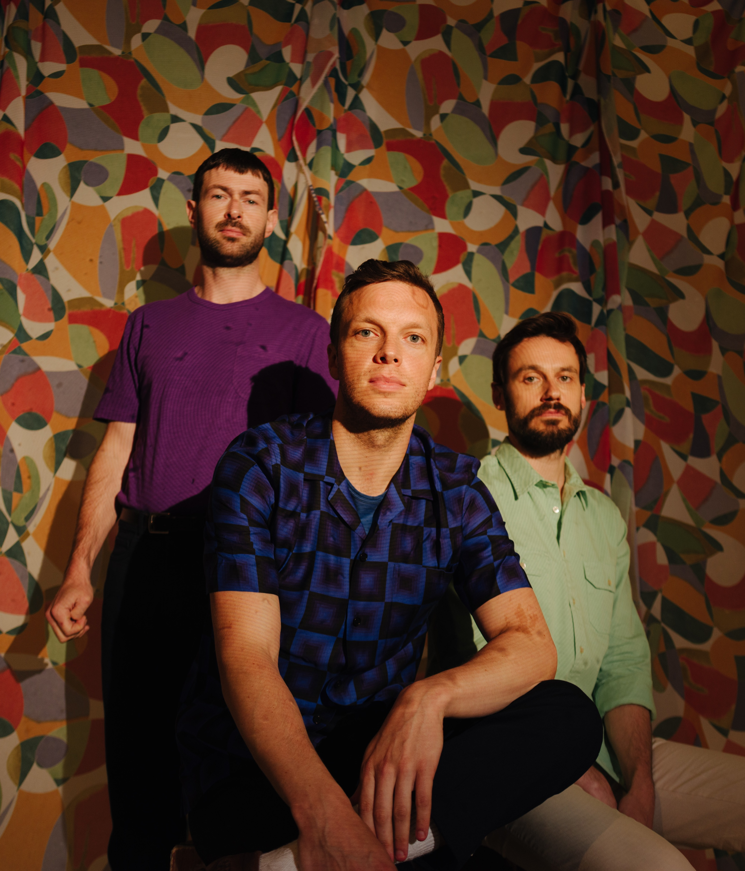

Download hi res photo [here](https://www.dropbox.com/sh/sawh9cxws8fuax0/AAATa_xc8LaMc-3l7WymtBVna/Other%20Selects/DW_B4624.jpg?dl=0)

**Friendly Fires** have announced a very special UK tour to celebrate the 15-year anniversary of the release of their seminal debut **‘Friendly Fires’,** as well as reissues of the album and **‘Paris’.** The live dates follow sold-out shows earlier this year in London and Leeds, and as the band gear up to perform a homecoming show at St Albans Arena on 24th August.

On the new dates and reissues the band say –

*“We‘ve had such a ridiculously fun time playing these first album shows that we‘re going to spread the love to some more corners of the UK. Join us to raise a glass and have a dance – it’s gonna be special.*

*“We’re also going to mark the occasion with 15th anniversary re-issues of the vinyl edition of the ‘Friendly Fires’ LP, and the ‘Paris’ 12” complete with its iconic Aeroplane remix. Both of these have been out of print for an age, so we thought it’d be good for a few more people to be able to own them. They’re being printed on glorious gold and silver vinyl, and sounding extra-specially luxurious because of it.”*

**Live dates –**

Thu 24 August St Albans Arena

Thu 23 November Nottingham Rock City

Fri 24 November Manchester O2 Victoria Warehouse

Sat 25 November Birmingham O2 Institute

Tue 28 November Leeds Beckett Students Union

Thu 30 November London Troxy

Fri 1 December Brighton Dome

Tickets go on general sale at 10am on Friday 26th May from www.gigsadtours.com and [www.ticketmaster.co.uk](http://www.ticketmaster.co.uk).

Alongside this the band have announced two special limited-edition vinyl reissues. The album ‘Friendly Fires’ will come on silver vinyl, whilst a 12” of the ‘Paris’ remixes by Aeroplane and Justus Kohncke will come on gold vinyl. These will both be released by XL Recordings on 8th September. Pre-order the reissue [here](https://shop.xlrecordings.com/release/389385-friendly-fires-friendly-fires-15th-anniversary).

‘Friendly Fires’ was the debut album from the St Albans-three piece, Ed MacFarlane, Edd Gibson and Jack Savidge. Featuring hit singles ‘Jump In the Pool’ and ‘Paris’, it was an era-defining record. It launched the band to huge critical and commercial success. It was nominated for the Mercury Prize and a Brit Award, and touring the band were an essential act, playing the biggest festivals in the world. The record transcended the punk-funk scene of the time and this show will be a celebration of this modern classic.

[INSTAGRAM](https://www.instagram.com/friendlyfires/?hl=en) / [SPOTIFY](https://open.spotify.com/artist/3mZqziCJj4pq3P2VBpmK6p?si=3tTmXD63SBOnmoZOW-1Fxg) / [WEBSITE](https://friendlyfires.co.uk/)

